

**INDIVIDUAL ASSIGNMENT**

**TECHNOLOGY PARK MALAYSIA**

**CT047-3-2-SPCC-LAB-11**

**SYSTEM PROGRAMMING AND COMPUTER CONTROL**

**APU2F2411CS(AI)**

**Product: Washing Machine**

**Application Utilized: LabVIEW**

**Lecturer: Mrs. Nor Azlina Binti Abd Rahman**

|  |  |  |  |
| --- | --- | --- | --- |
| **No.** | **Student Name** | **TP Number** | **Signature** |
| 1. | Manreen Kaur A/P Jagjit Singh | TP071290 | Mrn |

Table of Contents

Abstract 4

Introduction 5

Section 6

Front Panel 6

Client Log In & Operate Washing Machine 10

Back Panel 10

The images below are related to the login system. 10

The images below are related to the washing machine user interface, 17

Controller 24

Washing Machine 30

Limitations/Extensions/Suggestions 42

User Manual 44

Conclusion 49

Appendices 50

References 57

No table of figures entries found.

# Abstract

The Washing Machine Controller System is an advanced prototype developed to automate and optimize washing machine operations in a modern laundry shop setting. Designed and implemented using LabVIEW, this system allows for the seamless management of multiple machines through a centralized interface, ensuring operational efficiency and user convenience. The system incorporates power control, water regulation, motor management for different washing modes, and a secure PIN-based authentication mechanism. The prototype leverages software-simulated sensors to emulate real-world machine functionalities and provides real-time monitoring through TCP/IP communication. Additionally, the system integrates an audio alert in WAV format and utilizes a text file for user authentication. This report provides a comprehensive analysis of the system’s design, functionality, front panel UI, washing process automation, sensor integration, limitations, and potential future enhancements, laying the groundwork for further advancements in intelligent laundry automation.

# Introduction

The increasing demand for automated and intelligent laundry solutions has necessitated the development of more efficient washing machine control systems. Traditional washing machines require significant manual intervention, which can lead to inefficiencies in modern laundry shop settings. To address this issue, the proposed Washing Machine Controller System, developed using LabVIEW, aims to streamline laundry operations by integrating automation, security, and remote monitoring capabilities.

This system provides a centralized and secure method for managing multiple washing machines within a facility, improving both user convenience and operational efficiency. By utilizing software-simulated sensors, the system enables real-time monitoring of various washing processes, ensuring optimal performance. It also incorporates network communication through TCP/IP, allowing remote control and supervision of washing machines. To maintain security, the system employs a PIN-based authentication mechanism, ensuring that only authorized users can access and operate the machines.

A key feature of this system is its ability to automate essential washing processes such as water intake, cycle selection, soaking duration, rinsing, and drying. By reducing the need for manual intervention, it enhances efficiency and simplifies operations. The system also integrates critical safety measures, including door lock sensors and power-off controls, to ensure reliable and safe functionality. The user-friendly graphical interface further enhances usability, allowing users to easily select washing modes, set specific parameters, and monitor the entire process in real-time.

The development of this system focuses on creating an intuitive and secure interface that enhances user interaction. Implementing advanced machine control mechanisms ensures that washing cycles are managed effectively, improving overall operational efficiency. The integration of TCP/IP communication facilitates remote monitoring, enabling users to control and supervise washing processes from a distance. By combining automation, intelligent control, and real-time monitoring, the Washing Machine Controller System significantly enhances the efficiency, safety, and user experience in modern laundry facilities.

# Section

The Washing Machine Controller System is composed of several key components that work simultaneously to deliver efficient performance.

Front Panel  
Client Log In & Operate Washing Machine

1. Run the application

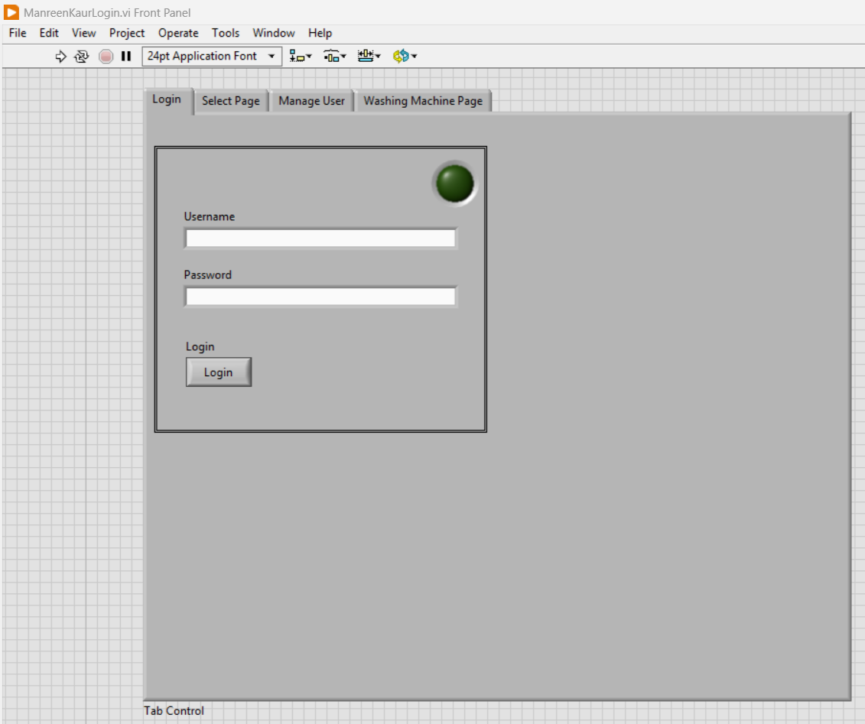First and foremost, users must launch the application by clicking operate and then run.

1. Login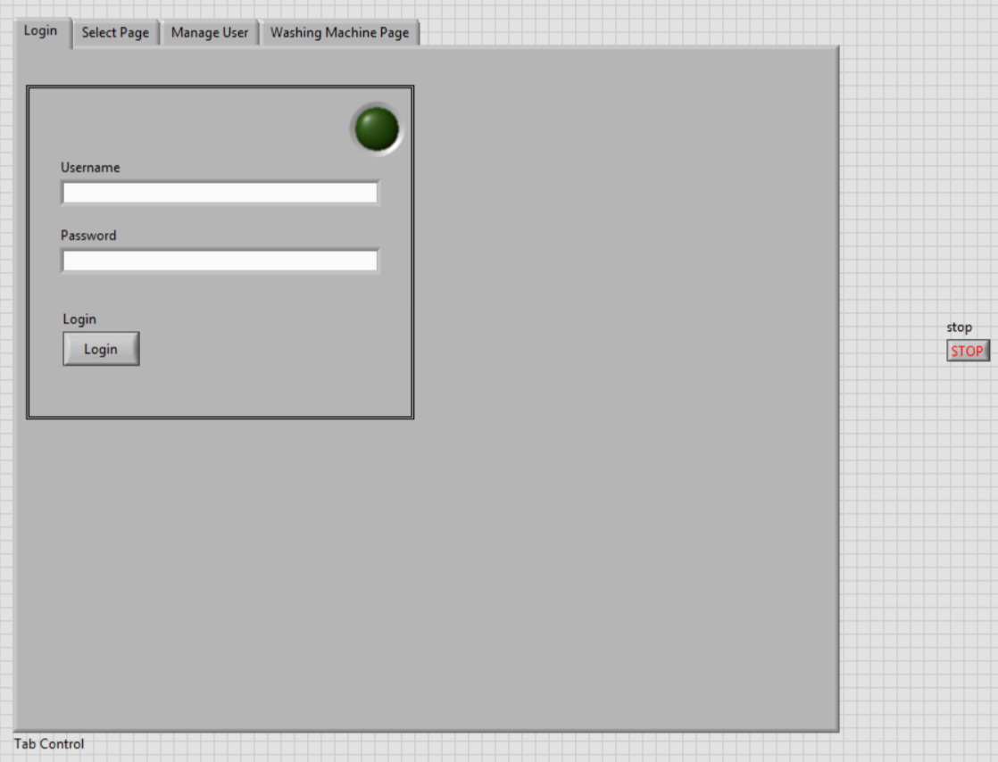  
   The Washing Machine Controller User Manual provides essential guidance for users to operate the system efficiently. Upon launching the application, users must log in using their assigned username and password. A successful login is indicated by a green light, while an incorrect attempt will not trigger any lights until the correct credentials are entered.
2. Menu Page

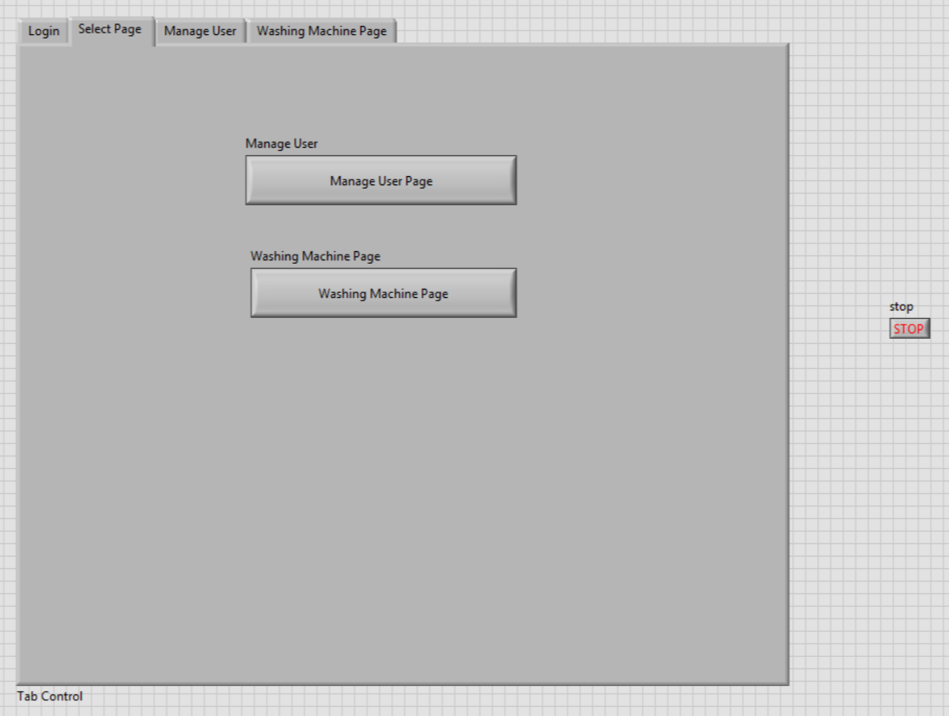

Once logged in, users will be directed to the menu page, where they can choose between managing user accounts or operating the washing machine.

1. Manage User

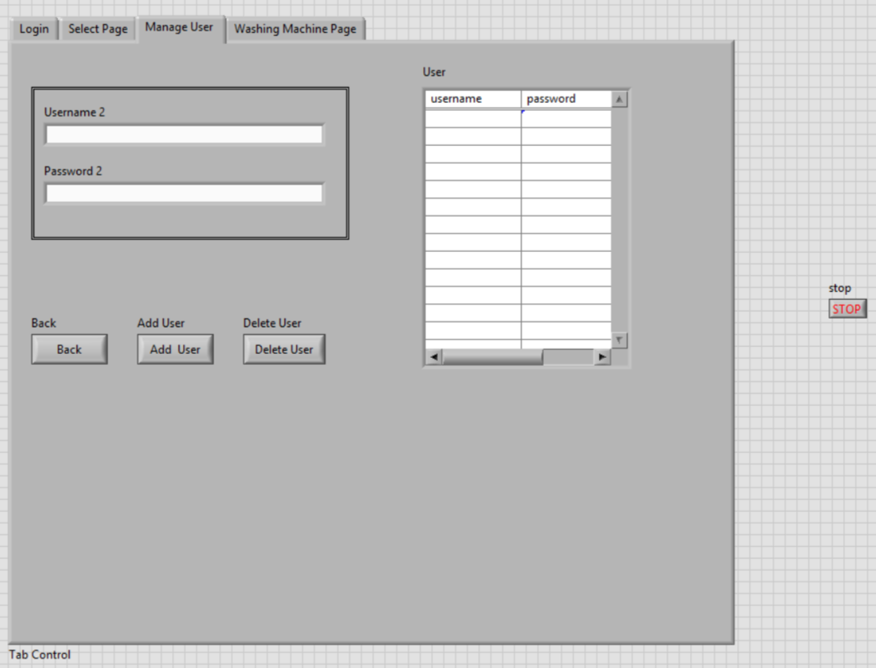

If users select the manage user page, they can add or delete usernames and passwords. Any newly added credentials will be automatically saved in the text file, allowing future logins. Conversely, deleted users will no longer have access, as their details will be removed from the system. Users can navigate back to the menu by clicking the "Back" button.

1. Washing Machine Page

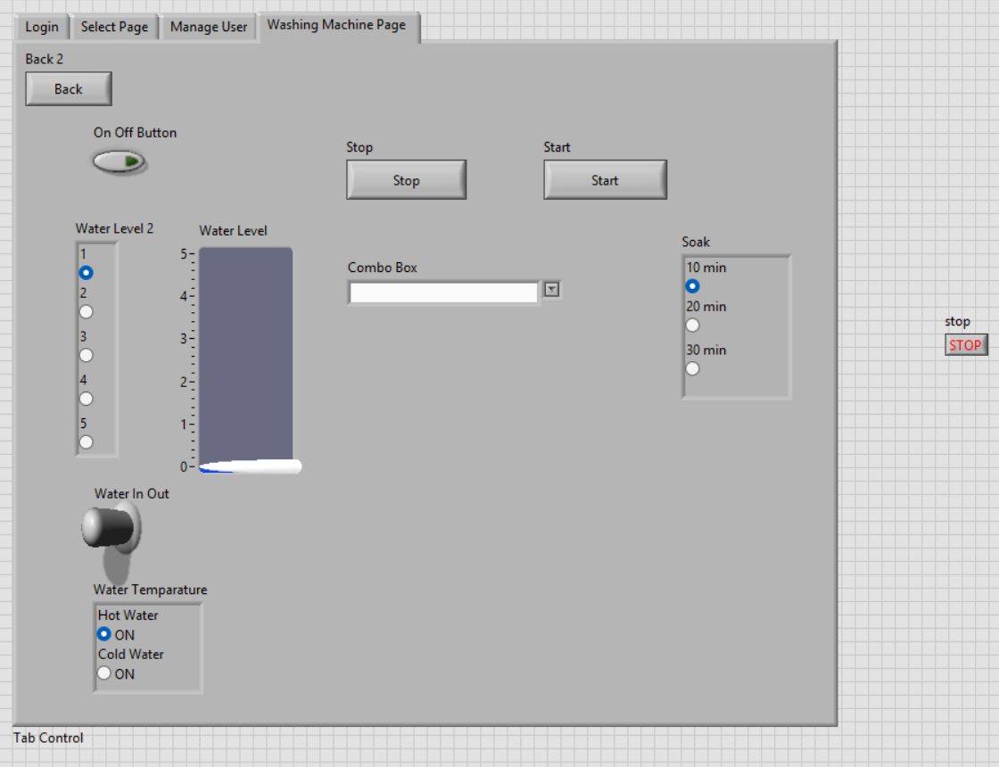

If users proceed to the washing machine page, they can control the machine's operations. The system allows users to turn the washing machine on or off and adjust the water level according to the amount of laundry, with the selected level displayed on the right icon. Additionally, users can set the water temperature to either hot or cold. Various washing modes are available, including normal wash, wash, soak, rinse, and dry. If selecting the soak function, users can choose a duration of 10, 20, or 30 minutes. Once all settings are configured, the user can start the washing process by clicking the "Start" button or terminate it using the "Stop" button.

## Client Log In & Operate Washing Machine

### Back Panel

The images below are related to the login system.

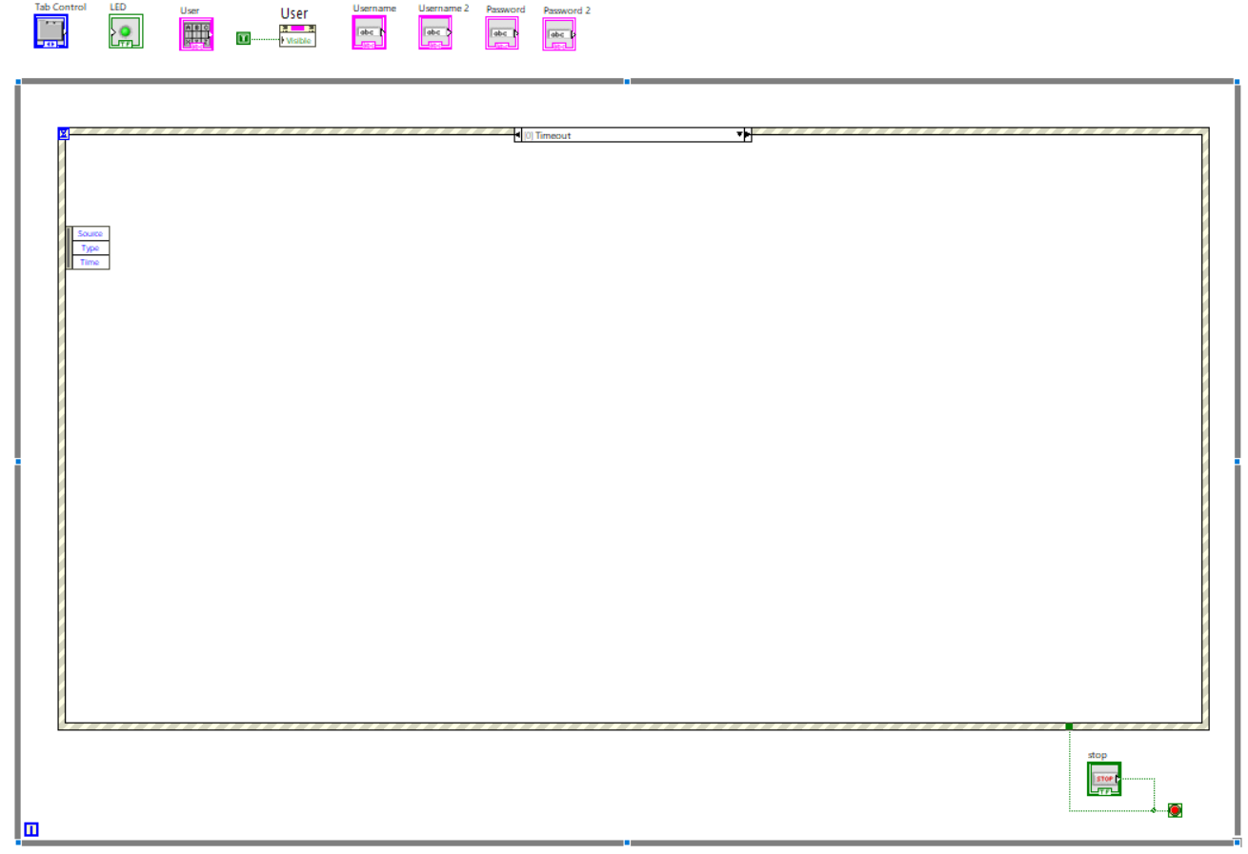

This image demonstrates the timeout for the login.

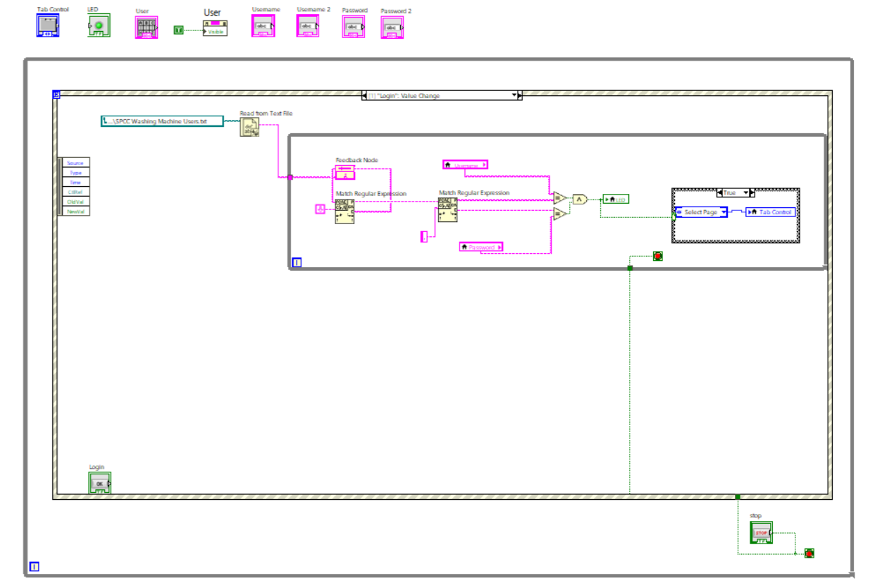

This image demonstrates the login, read from the text file based on the text file path pasted. When the feedback is given, it will match the expression to ensure the login is the correct username and password and the LED light will appear if it’s correct. User can select page based on the tab control once the login approves.

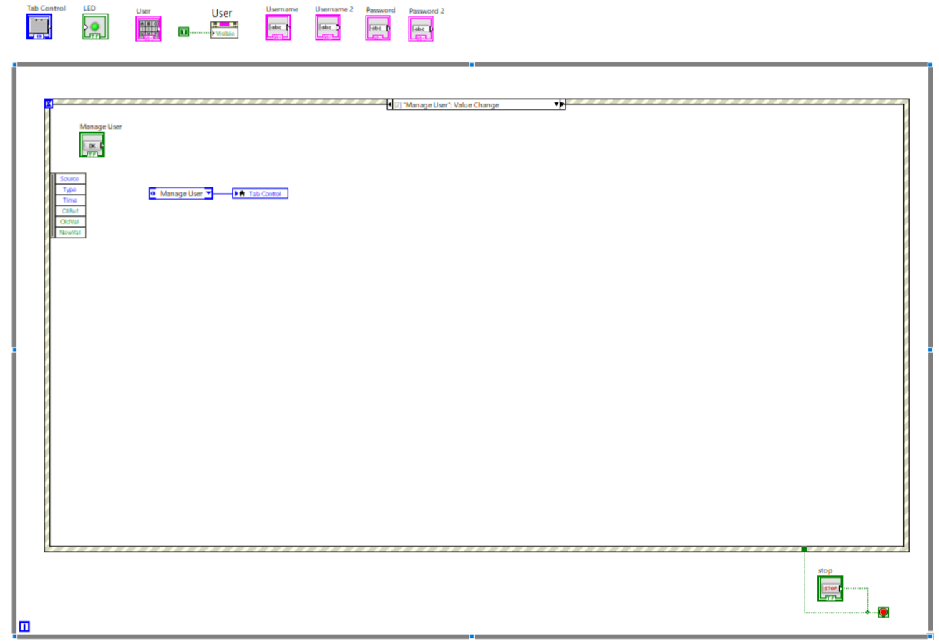

This image displays as the menu page which will show that the user chooses the manage user page.

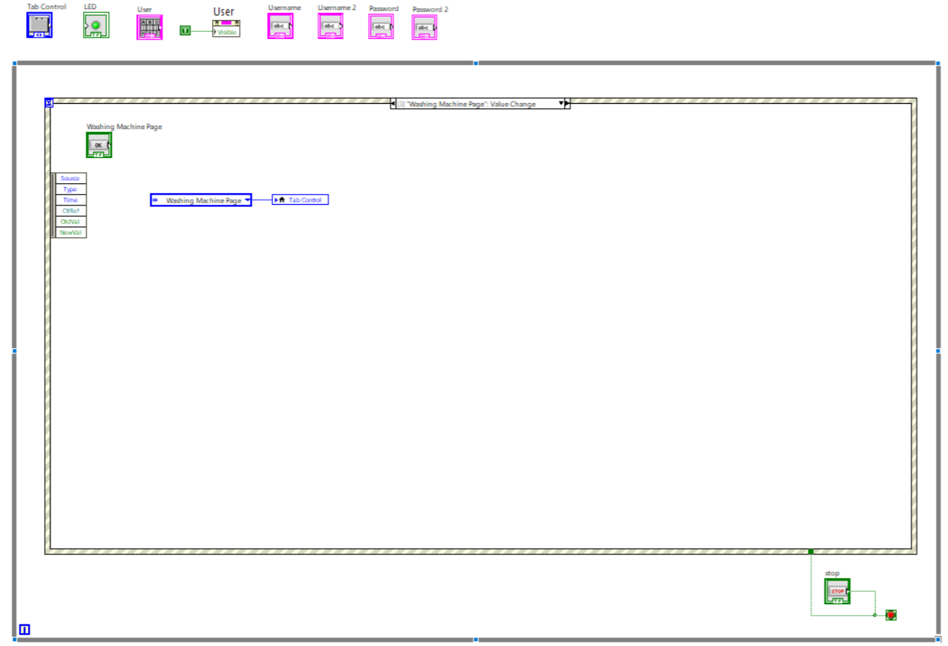

This image displays as the menu page which will show that the user chooses the washing machine page.

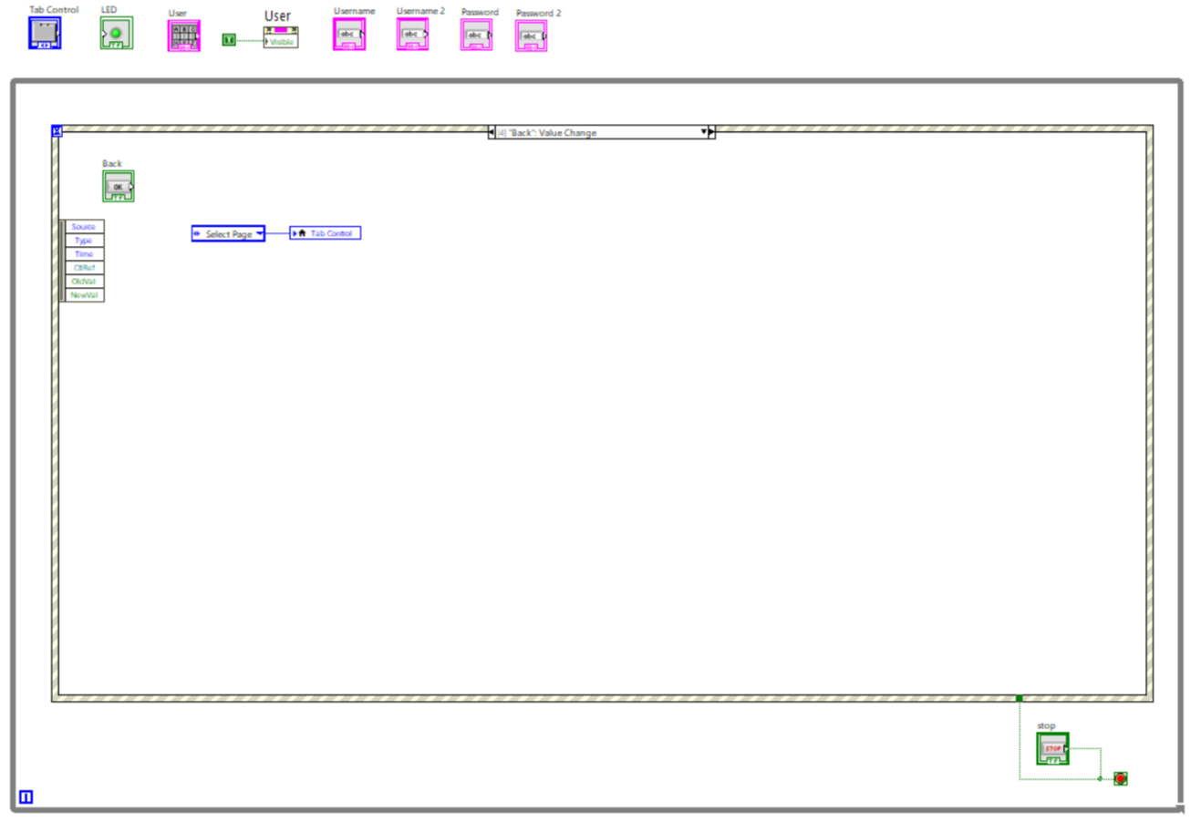  
This image shows when the user clicks back it will go back to the previous page.

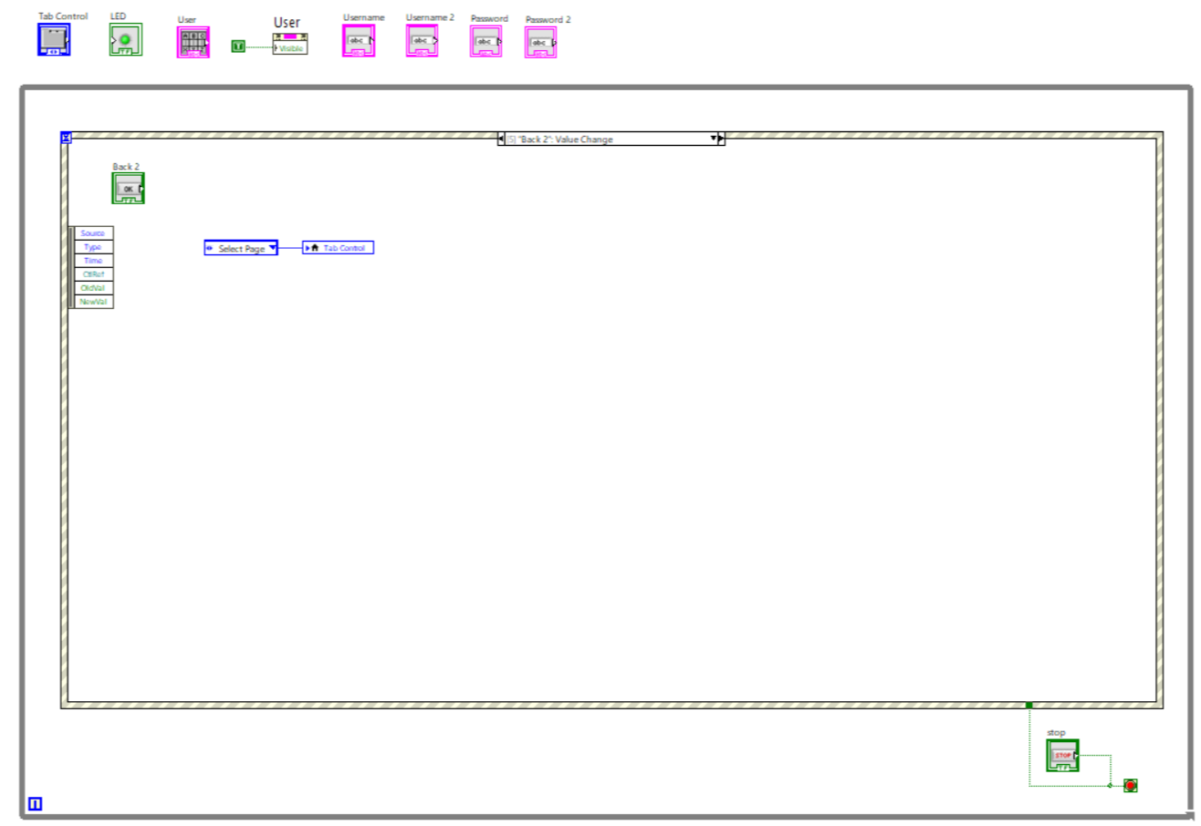

This image shows when the user clicks back it will go back to the previous page.

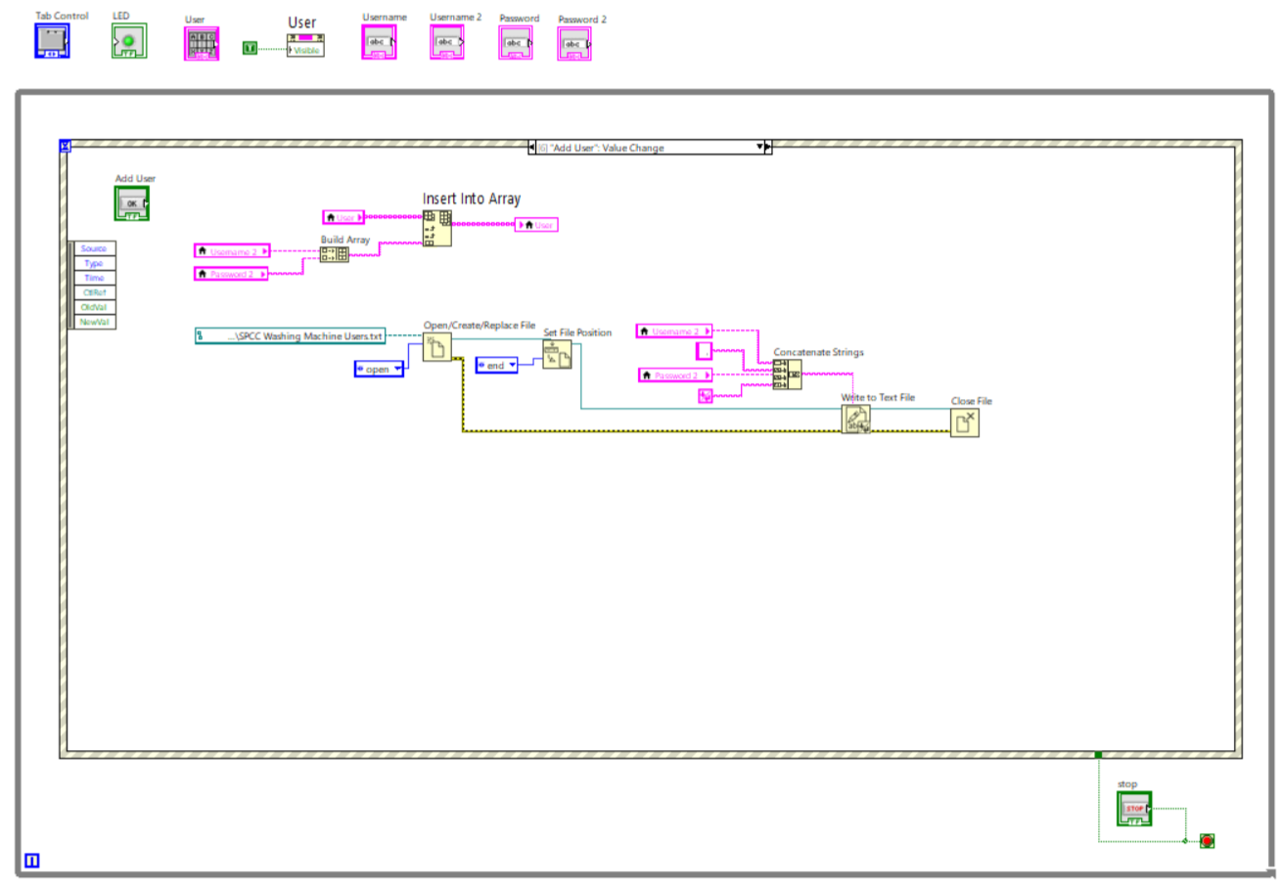

This image shows how to add users, username2 and password2 are built as an array before inserting to the User Array. Then to display users in the text file, the file must first be open.create/replace file using the function called File I/O, the file sets in position if the text file exists. Using the concatenate strings it will add the username and password by writing into the text file and close file.

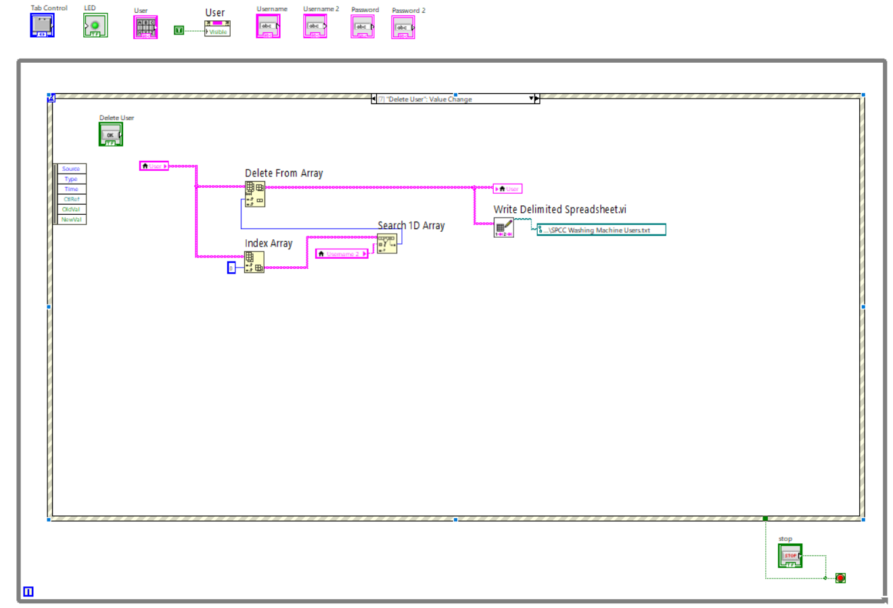

This image shows how to delete users, the user will be deleted from the array based on the user's text file. Then it will not display that user in the text file anymore as it’s no longer saved. The index is written 0 when searching in 1D array for that username selected.

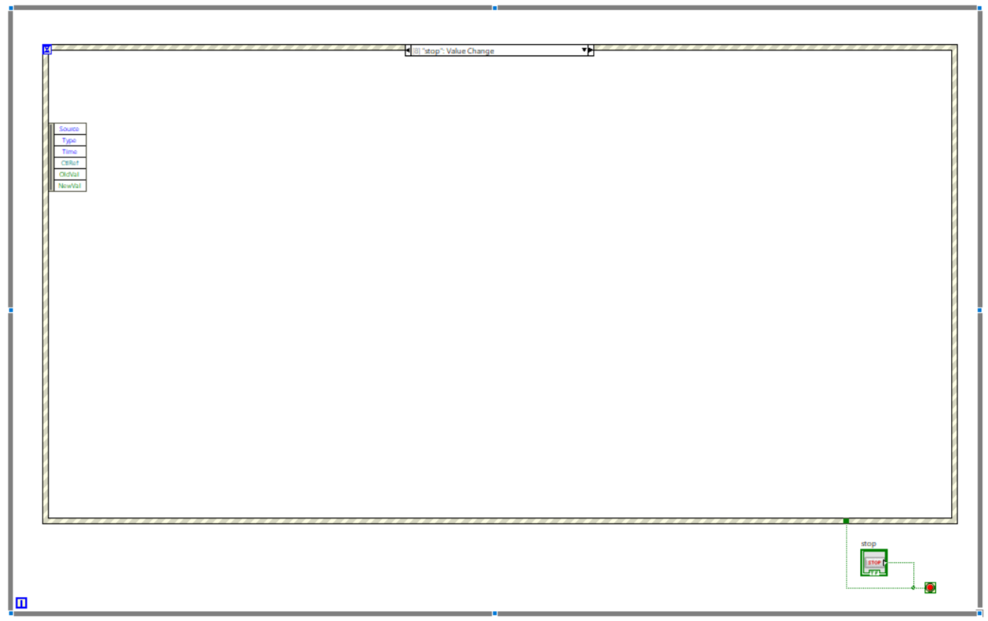

Based on this, users can choose to stop when click the stop button.

The images below are related to the washing machine user interface, demonstrating the washing machine temperature, water level, power off and on, and washing type within the user interface that is reading from the controller file.

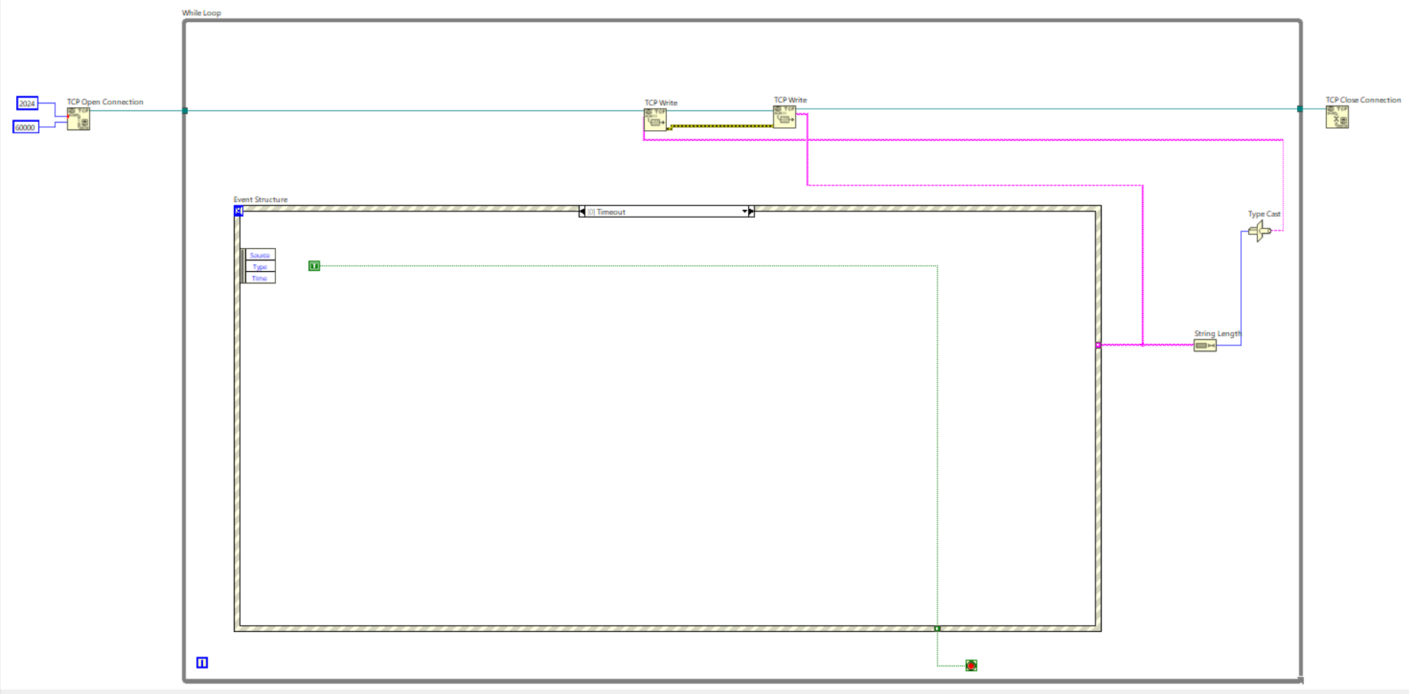

This image describes the timeout of the event.

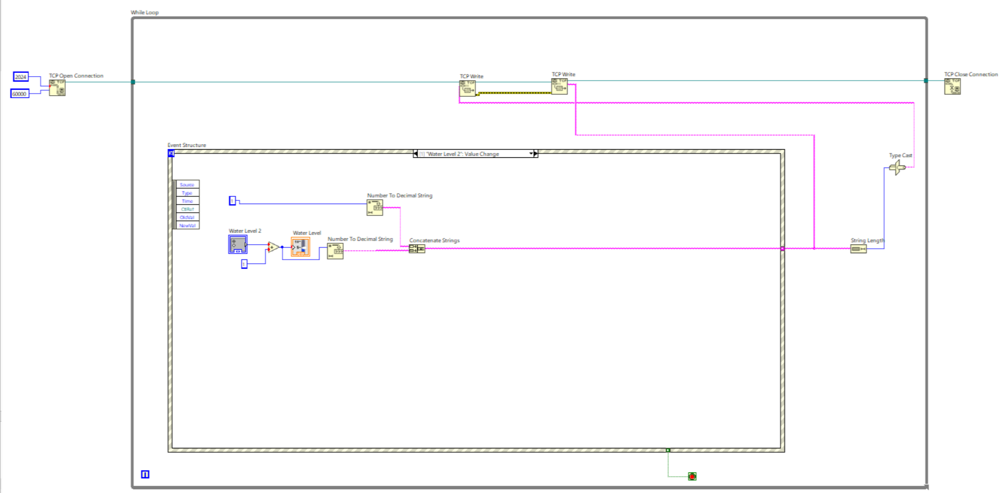

This image shows the water level when the user chooses, the system converts to the appropriate and suitable format so that the system can read the water level bar automatically.

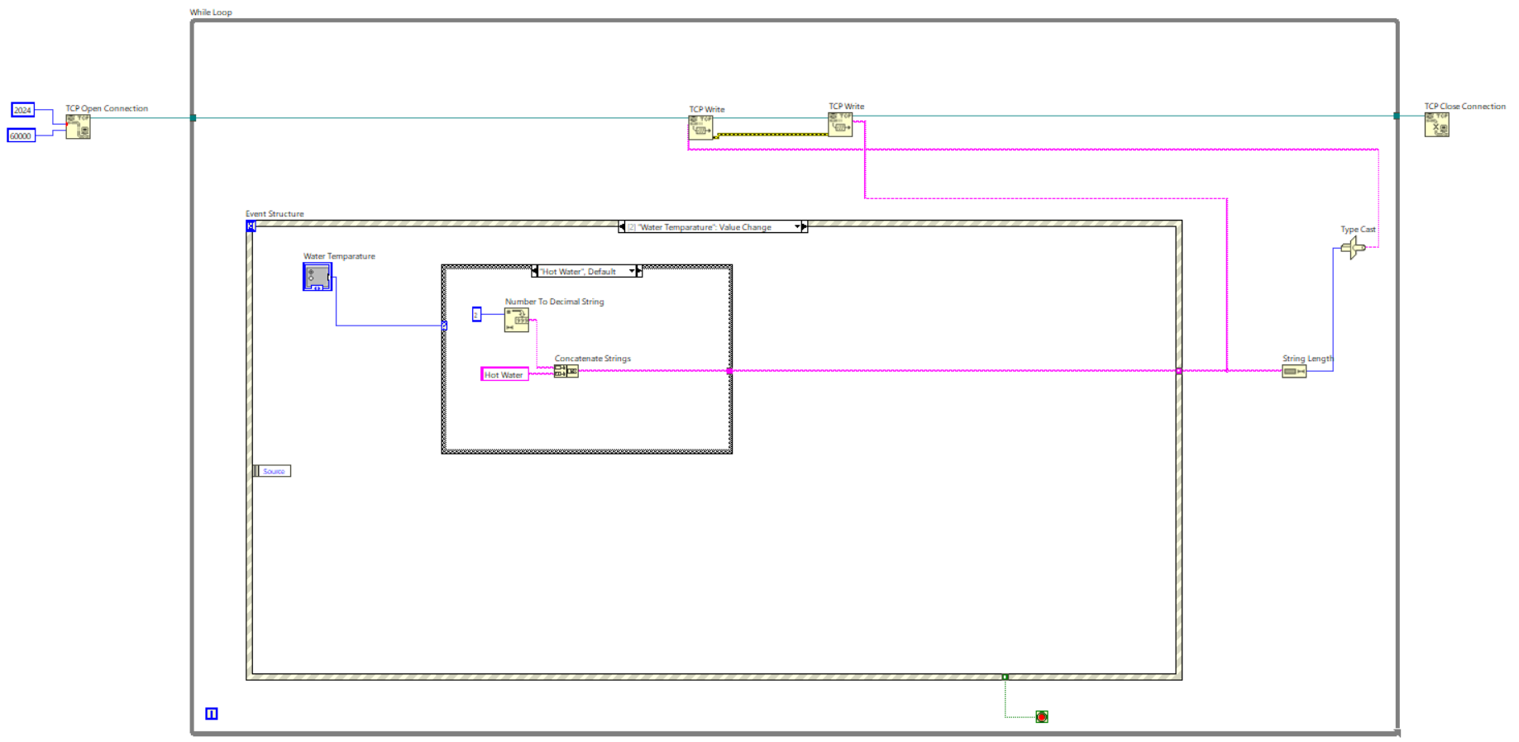

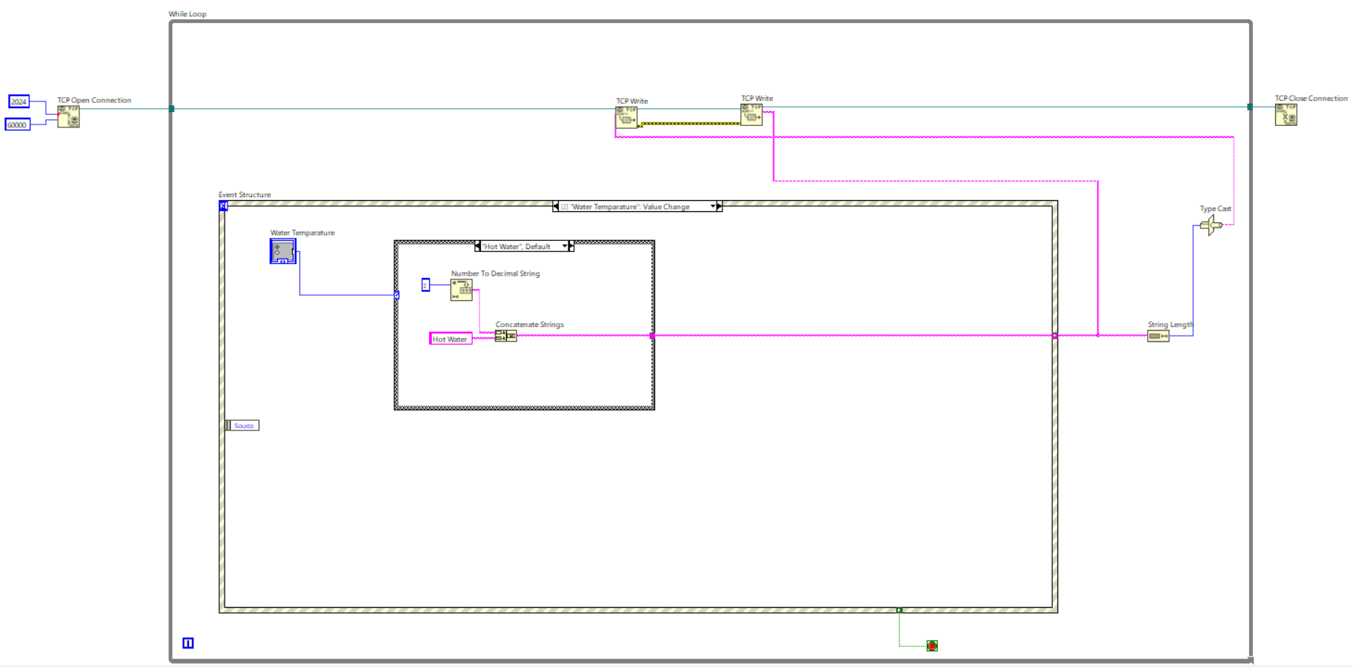  
This image displays the system of the hot-water temperature system. This system converts numbers to decimal strings to concatenate strings.

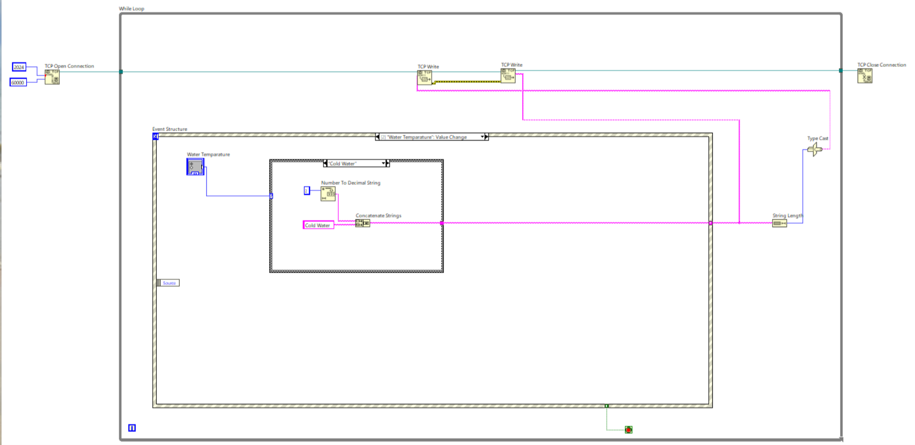

This image displays the system of the cold-water temperature system. This system converts numbers to decimal strings to concatenate strings.

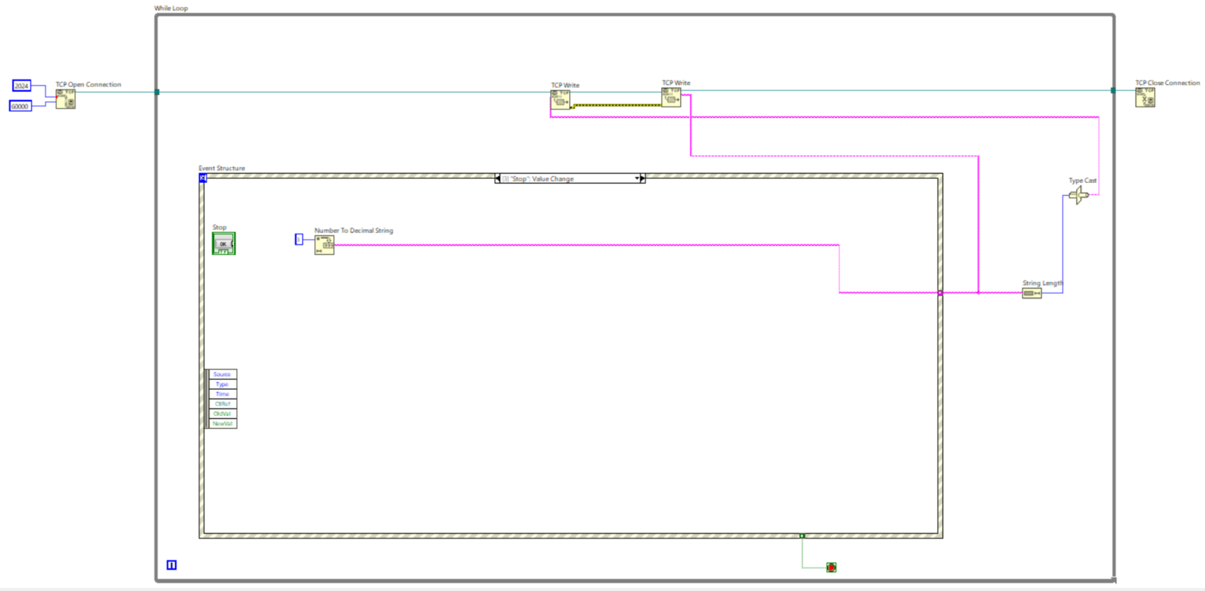

This image is the stop value change that converts the number to a decimal string.

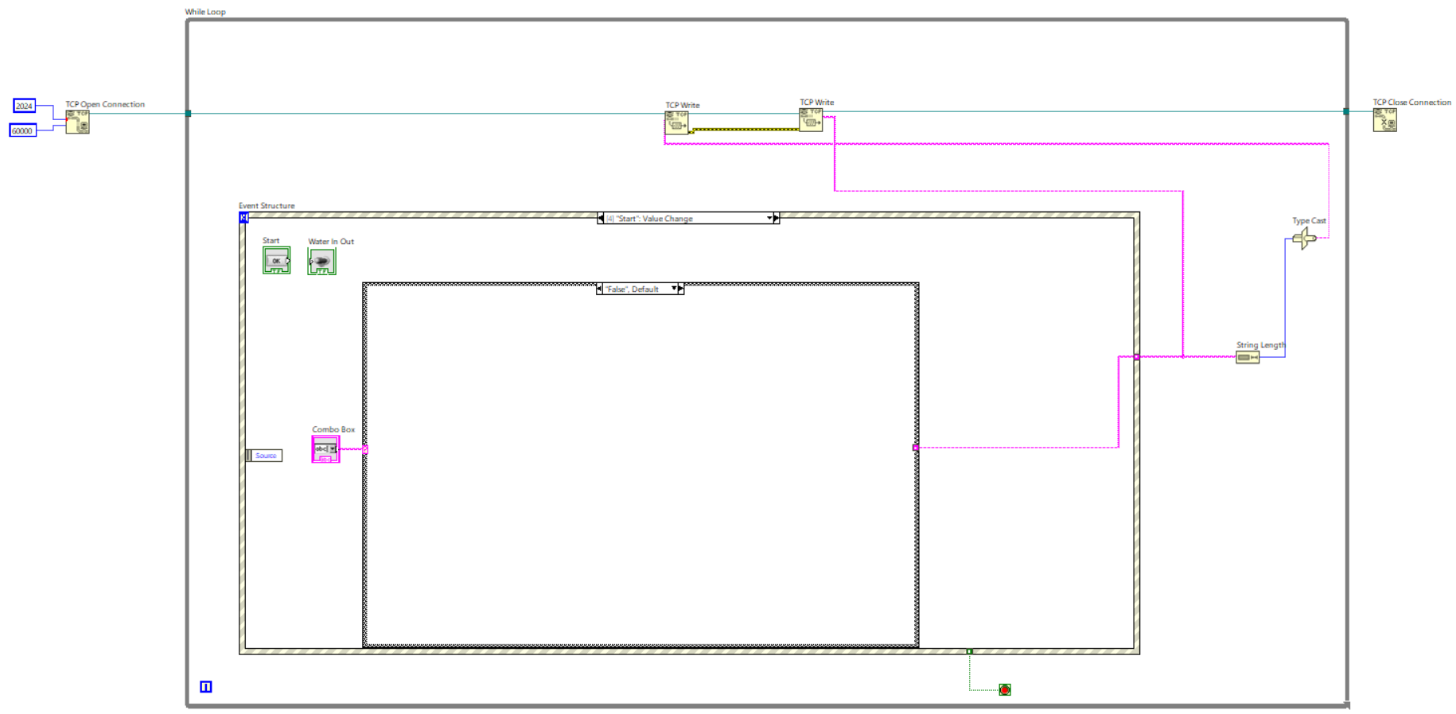  
This is just a default case structure.

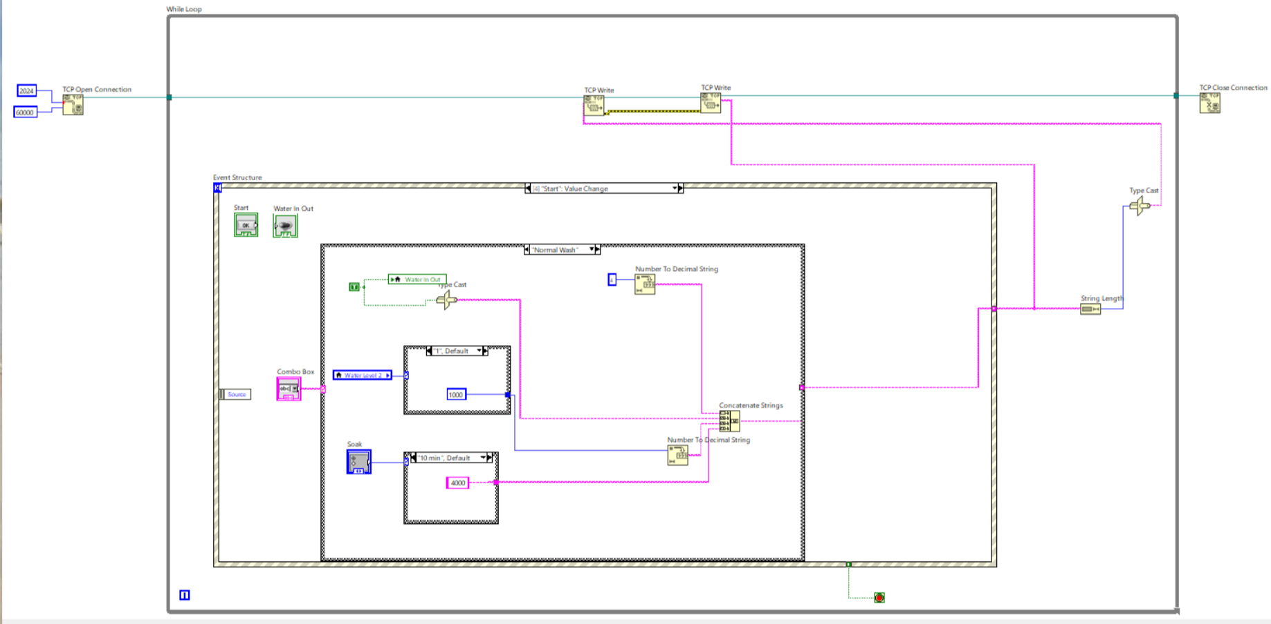

This is the normal wash procedure when the user selects from the combo box. First, the washing machine will perform water in and out since normal washing requires a water inlet. Then it will read the water level and the duration of the soak and convert the number to the string before concatenating the strings and in the end, it will perform the normal wash operation.

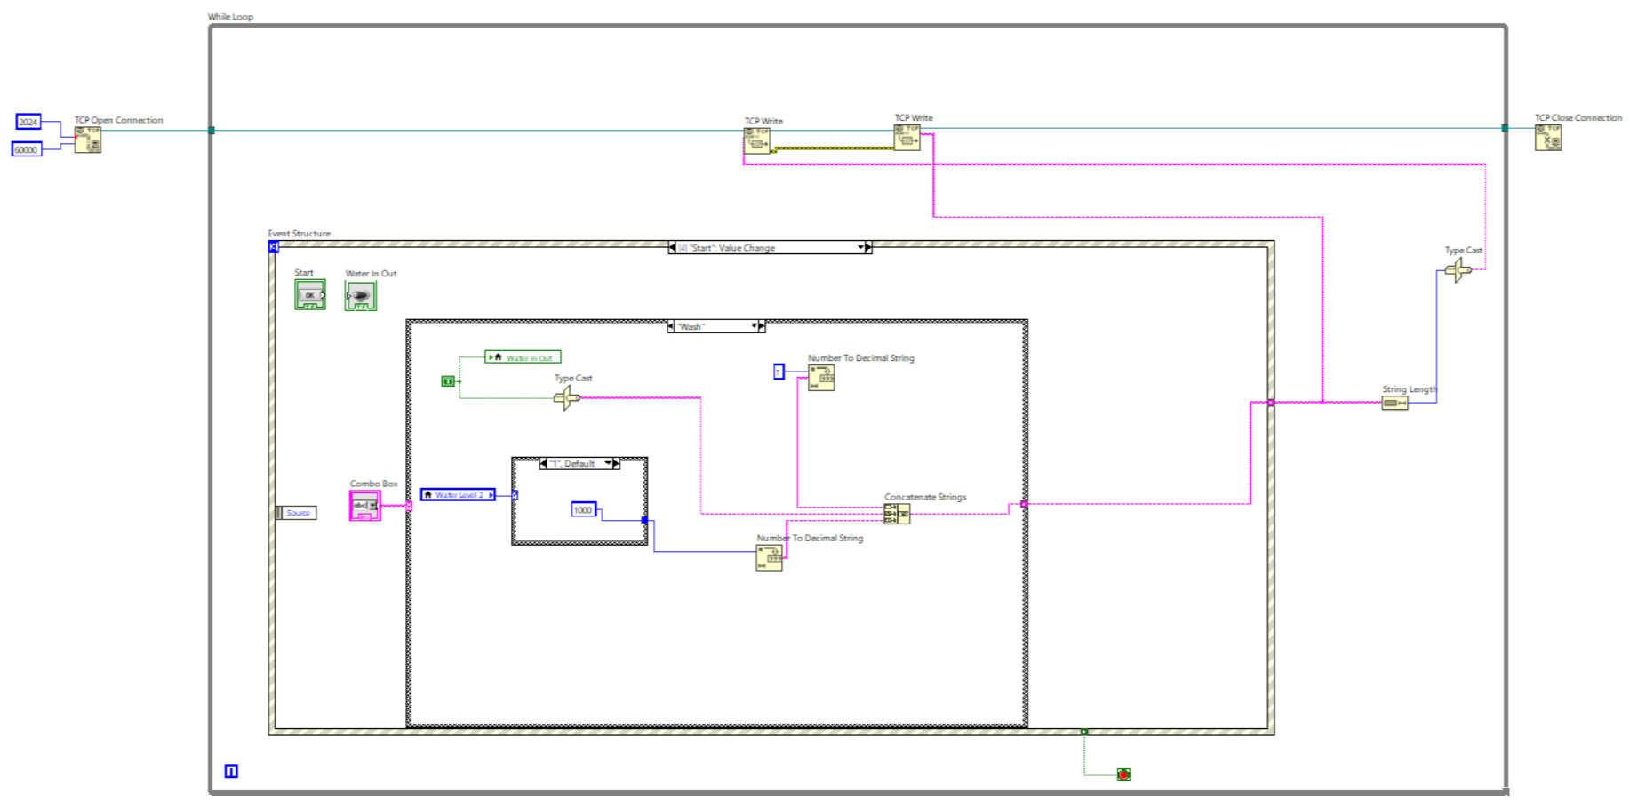

This is the wash procedure when the user selects from the combo box. First, the washing machine will perform water in and out since washing requires a water inlet. Then it will read the water level and convert the number to the string before concatenating the strings and in the end, it will perform the wash operation.

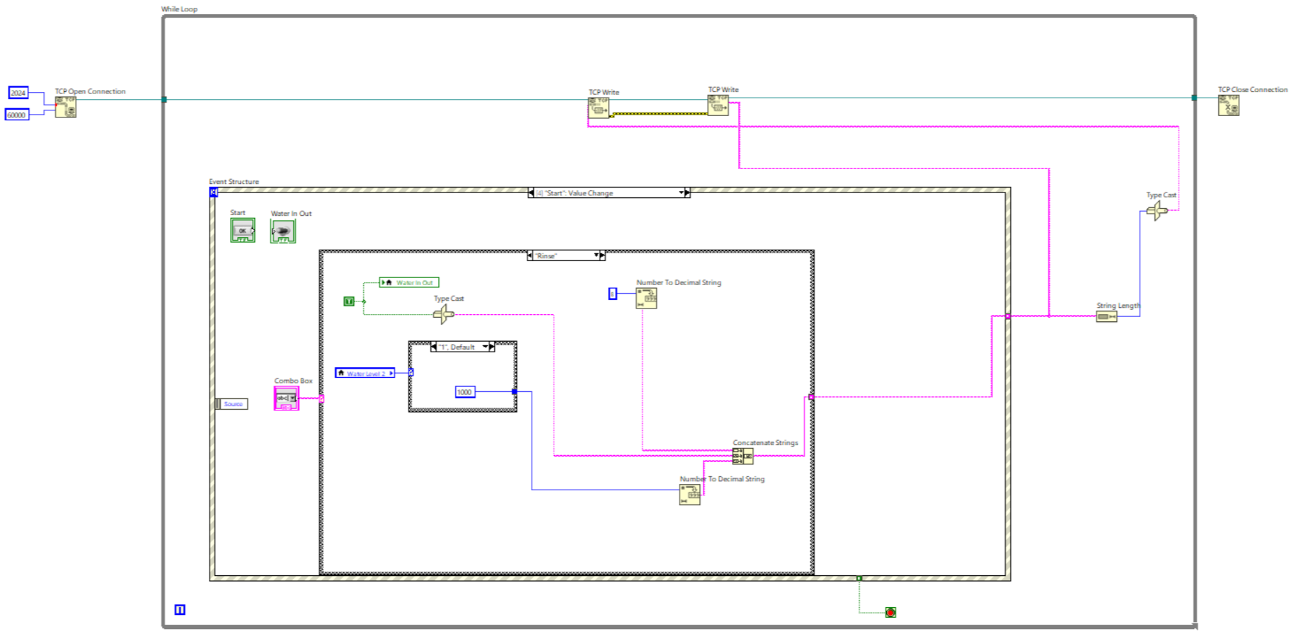

This is the rinse procedure when the user selects from the combo box. First, the rinse machine will perform water in and out since rinsing requires a water inlet. Then it will read the water level and convert the number to the string before concatenating the strings and in the end, it will perform the rinse operation.

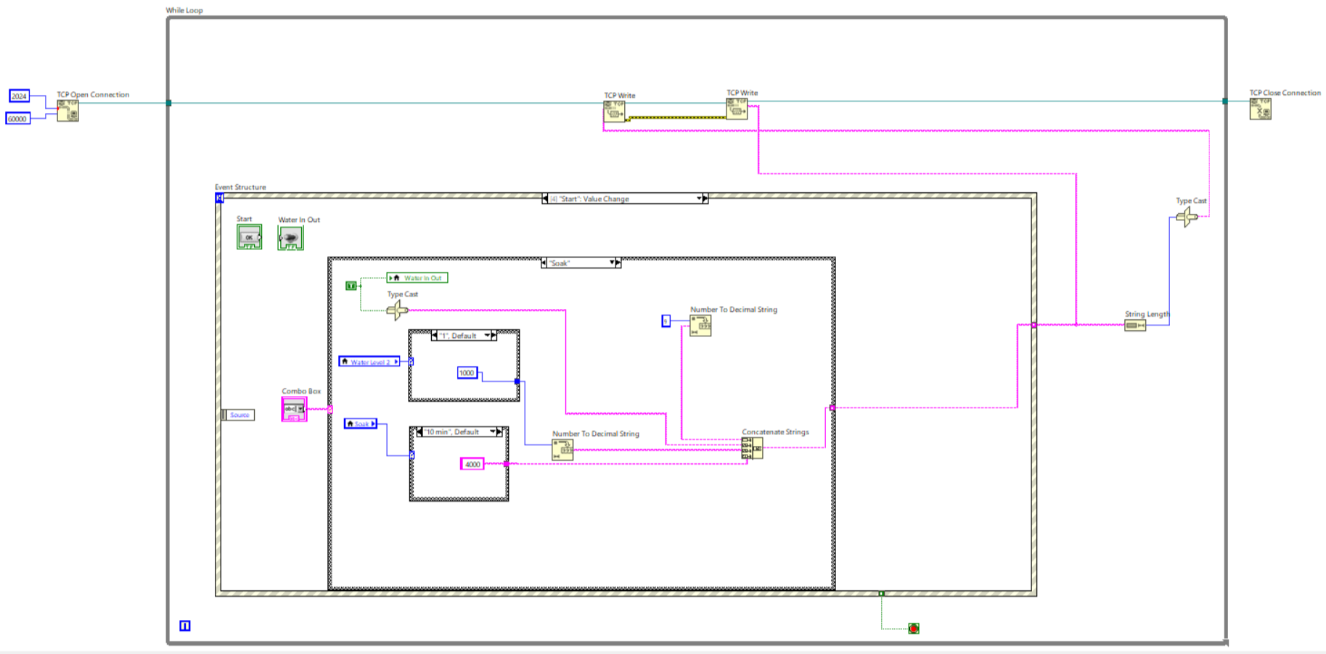

This is the soak procedure when the user selects from the combo box. First, the washing machine will perform water in and out since normal soaking requires a water inlet. Then it will read the water level and the duration of the soak and convert the number to the string before concatenating the strings and in the end, it will perform the soak operation.

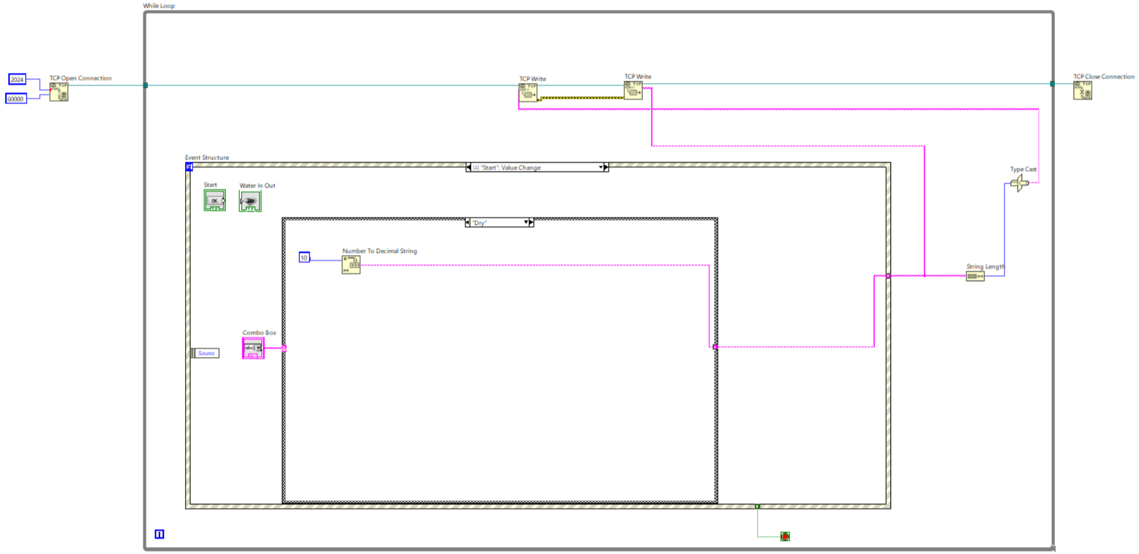

This is the dry procedure when the user selects from the combo box. It converts the number to a decimal string for the duration of the drying step is performed.

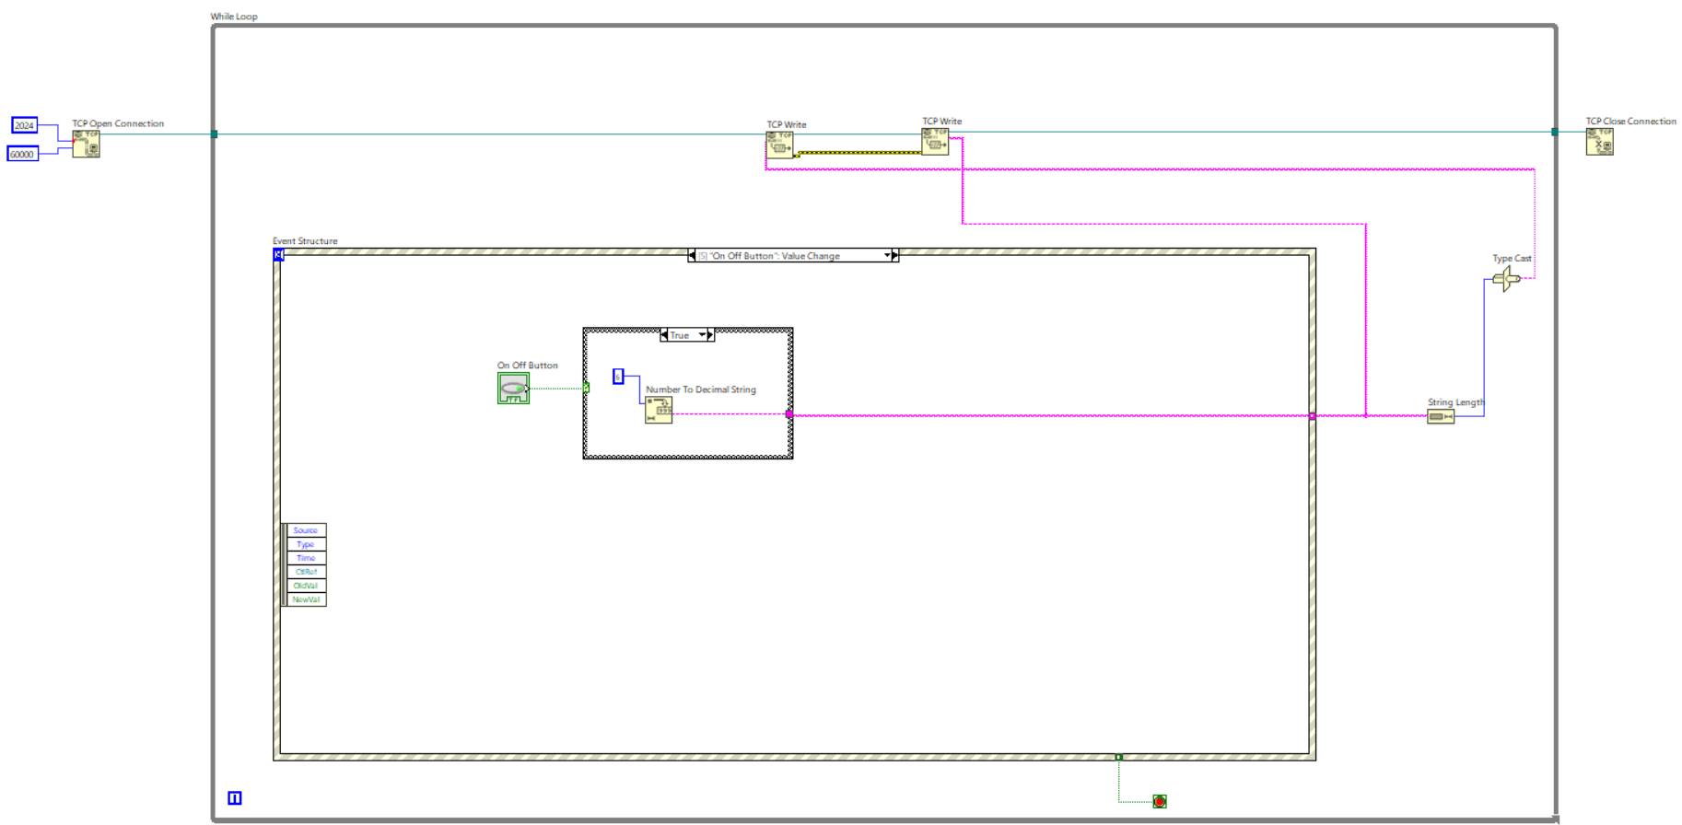  
This image demonstrates the power on and off button. It will convert the number to a decimal string to find out if the user would like to turn the washing machine on or off. By reading the numeric value it will automatically operate.

### Controller

The images below demonstrate the washing machine temperature, water level, power off and on, and washing type within the controller file that will be used for the washing machine user interface specially in the washing machine page.



This image describes the timeout of the event.



This image shows the water level when the user chooses, the system converts to the appropriate and suitable format so that the system can read the water level bar automatically.

  
This image displays the system of the hot-water temperature system. This system converts numbers to decimal strings to concatenate strings.



This image displays the system of the cold-water temperature system. This system converts numbers to decimal strings to concatenate strings.



This image is the stop value change that converts the number to a decimal string.

  
This is just a default case structure.



This is the normal wash procedure when the user selects from the combo box. First, the washing machine will perform water in and out since normal washing requires a water inlet. Then it will read the water level and the duration of the soak and convert the number to the string before concatenating the strings and in the end, it will perform the normal wash operation.



This is the wash procedure when the user selects from the combo box. First, the washing machine will perform water in and out since washing requires a water inlet. Then it will read the water level and convert the number to the string before concatenating the strings and in the end, it will perform the wash operation.



This is the rinse procedure when the user selects from the combo box. First, the rinse machine will perform water in and out since rinsing requires a water inlet. Then it will read the water level and convert the number to the string before concatenating the strings and in the end, it will perform the rinse operation.



This is the soak procedure when the user selects from the combo box. First, the washing machine will perform water in and out since normal soaking requires a water inlet. Then it will read the water level and the duration of the soak and convert the number to the string before concatenating the strings and in the end, it will perform the soak operation.



This is the dry procedure when the user selects from the combo box. It converts the number to a decimal string for the duration of the drying step is performed.

  
This image demonstrates the power on and off button. It will convert the number to a decimal string to find out if the user would like to turn the washing machine on or off. By reading the numeric value it will automatically operate.

## Washing Machine

The images below are related to the washing machine system of how it operates.

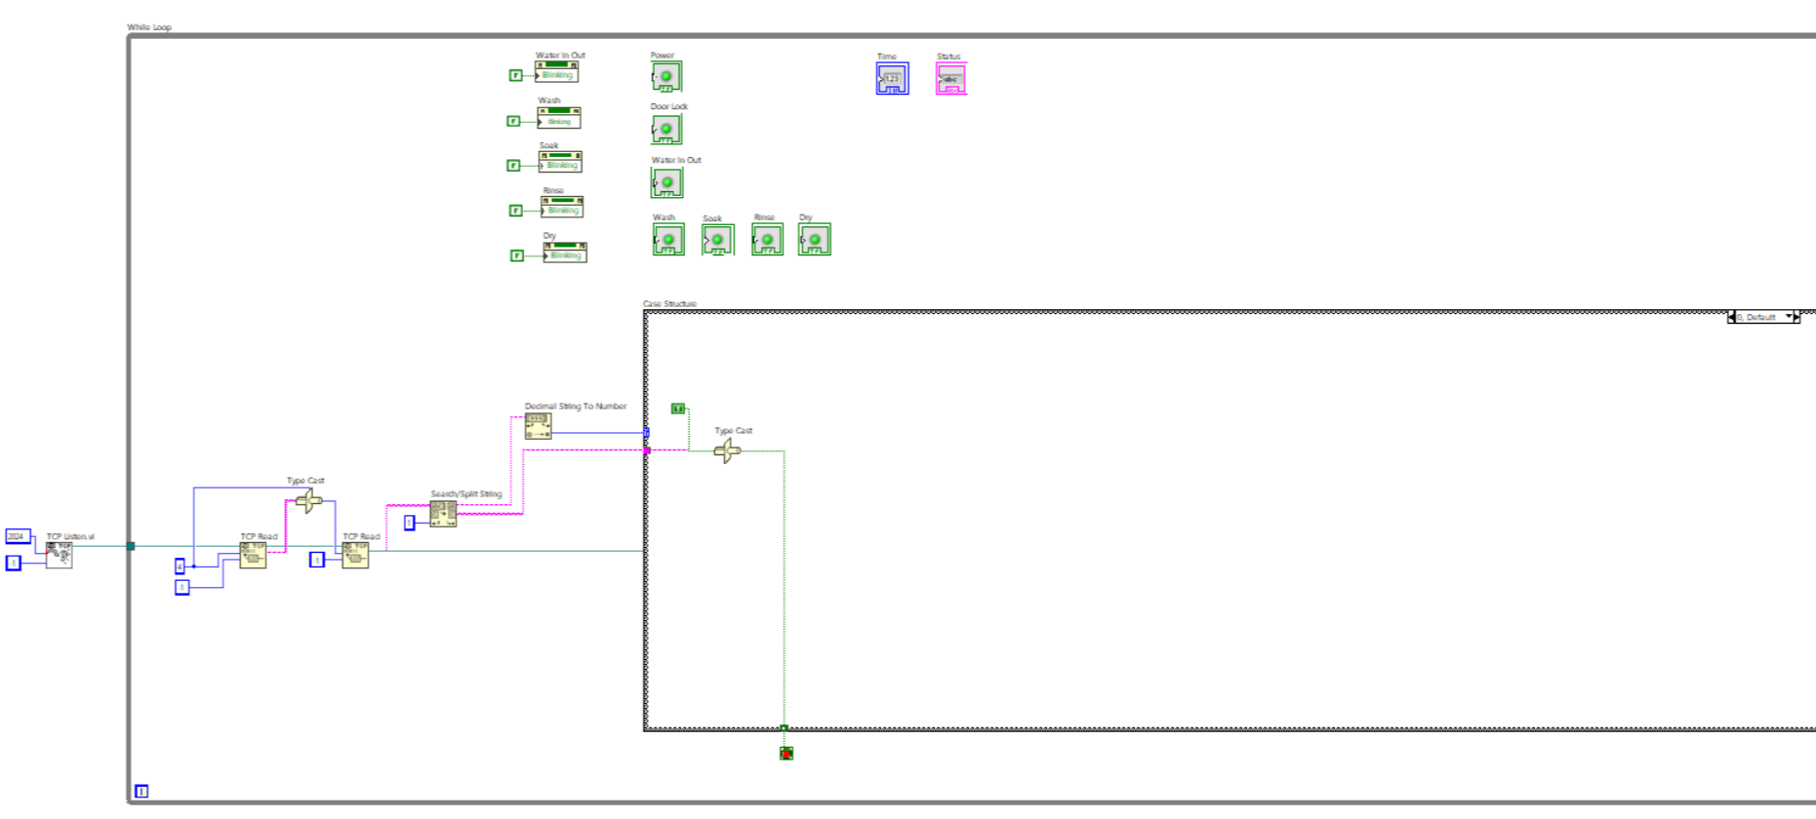

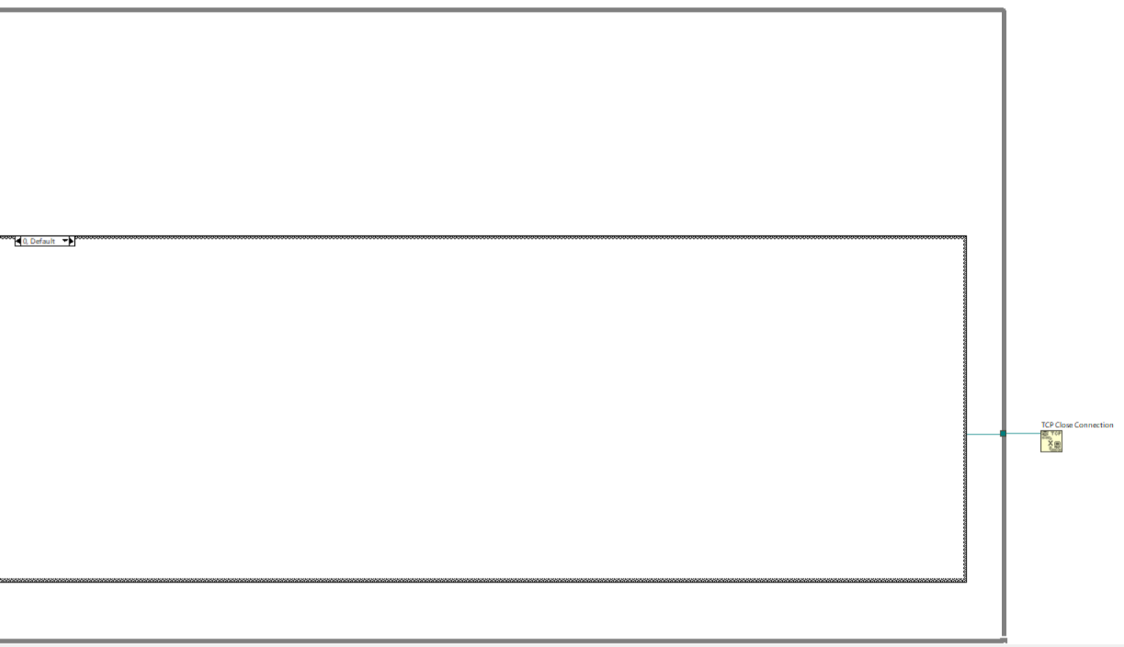  
  
TCP communication is used to receive and process commands for the washing machine system remotely. The TCP Listen.vi, which listens for incoming connections on port 2024, allows a remote system to send commands. The TCP Read functions then receive data, with the first reading a fixed 4-byte message and the second retrieving additional information. The received data is processed through a Type Cast function to ensure compatibility. A Search/Split String block extracts relevant commands, while the Decimal String to Number function converts numerical values for parameters such as water level, washing duration, or temperature. The Case Structure interprets these commands, determining the appropriate washing machine action, such as starting, stopping, or selecting a specific mode (normal wash, wash, soak, rinse, and dry). Finally, a Type Cast function and an indicator light display the processed result, with light signaling an error or a stop function. This system enables seamless remote operation of the washing machine, ensuring users can send commands over a network for various washing settings and operations. The While Loop is implemented to continuously listen for and process incoming TCP messages until a stop condition is met. The While Loop ensures that the washing machine system can receive multiple commands instead of terminating after processing just one. It keeps running as long as the stop condition is False (stop button). TCP Close Connection is used at the end of the communication process, responsible for safely terminating the connection between the client and the washing machine controller. Without closing the connection properly, the system could run into memory leaks, unresponsive behavior, or network congestion. When a stop condition is met in the While Loop or an error occurs, LabVIEW executes the TCP Close function to free up network resources and prevent issues with future connections. This ensures that when the washing machine session ends, the communication channel is properly shut down, making the system more reliable and efficient.

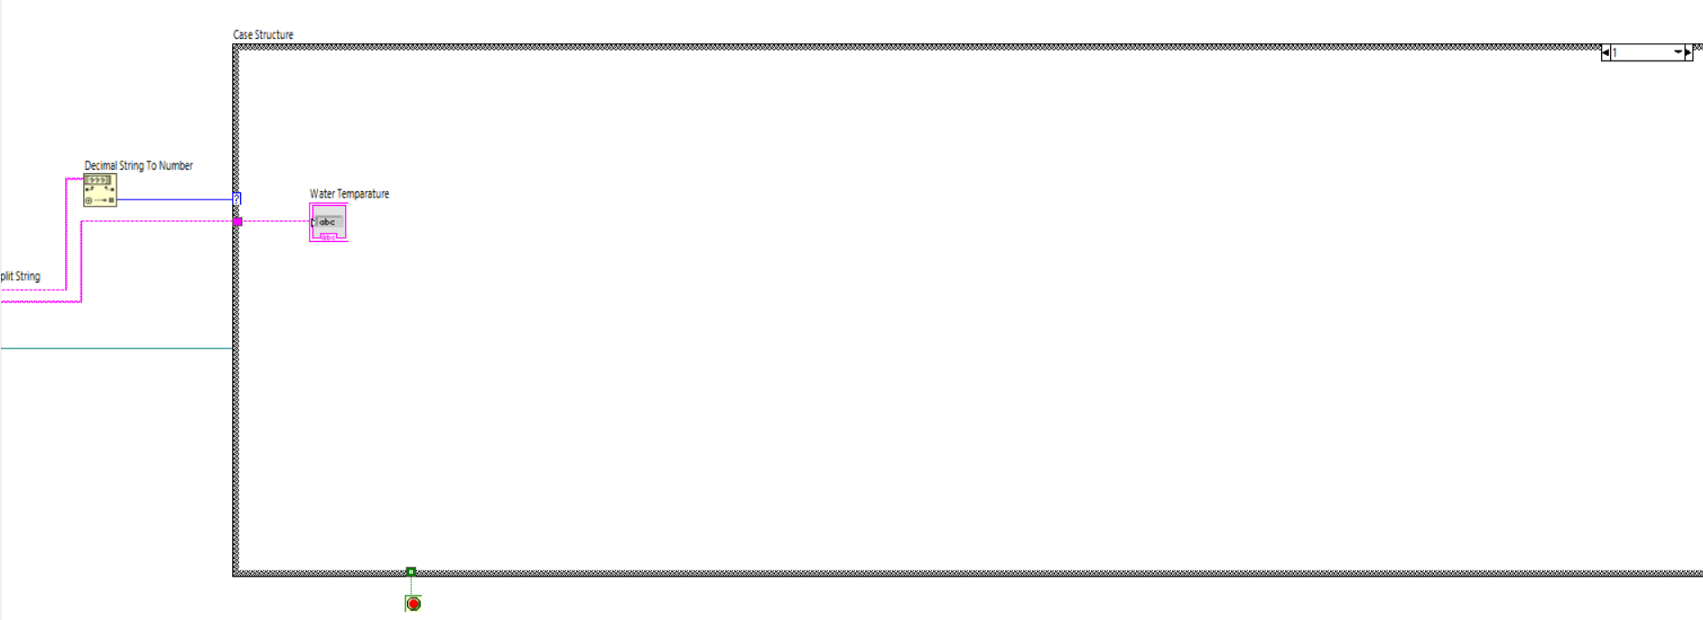

In case 1, which processes the water temperature selection. The system receives input through TCP communication, where data is read using TCP Read functions. The received data is then type-cast to the appropriate format before being split and processed. The "Decimal String to Number" function is used to convert the received string value into a numerical representation, ensuring that the system can correctly interpret the water temperature setting.

Inside Case 1, the processed numerical value is mapped to the Water Temperature indicator, which will display the selected water temperature on the user interface. This allows users to choose between different temperature settings, such as hot or cold water, depending on their washing preferences. Additionally, the case structure ensures that the system only executes water temperature-related operations when the appropriate command is received, making the washing machine system more modular and efficient.

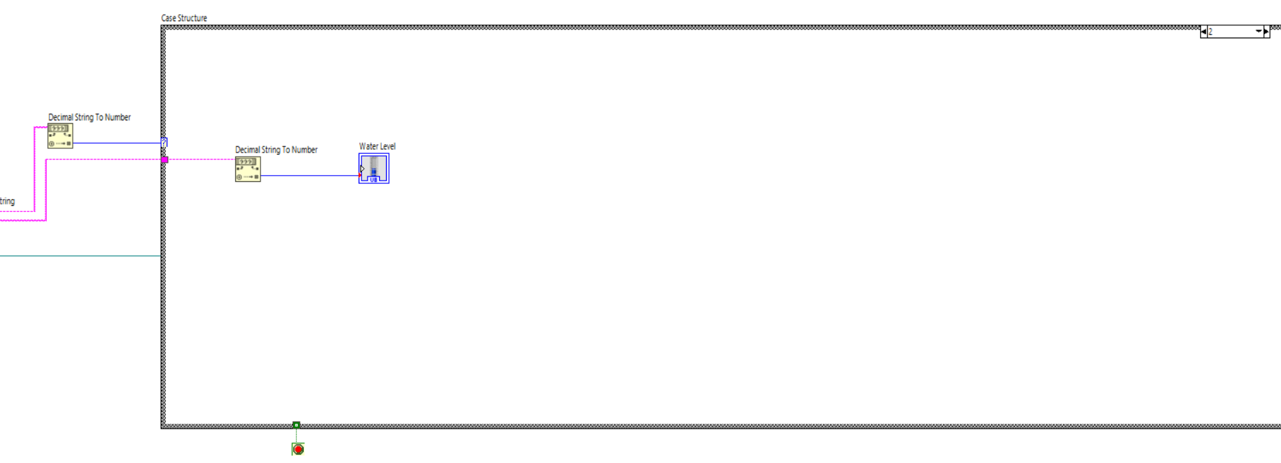

In case 2, which processes the water level selection (1-5). The system receives input through TCP communication, where data is read using TCP Read functions. The received data is then type-cast to the appropriate format before being split and processed. The "Decimal String to Number" function is used to convert the received string value into a numerical representation, ensuring that the system can correctly interpret the water level setting.

Inside Case 2, the processed numerical value is mapped to the Water Level indicator, which will display the selected water temperature on the user interface. This allows users to choose between different water level settings, such as 1, 2, 3, 4, or 5 (with 1 being the lowest water level whereas 5 is the highest), depending on their washing preferences. Additionally, the case structure ensures that the system only executes water level-related operations when the appropriate command is received, making the washing machine system more modular and efficient.

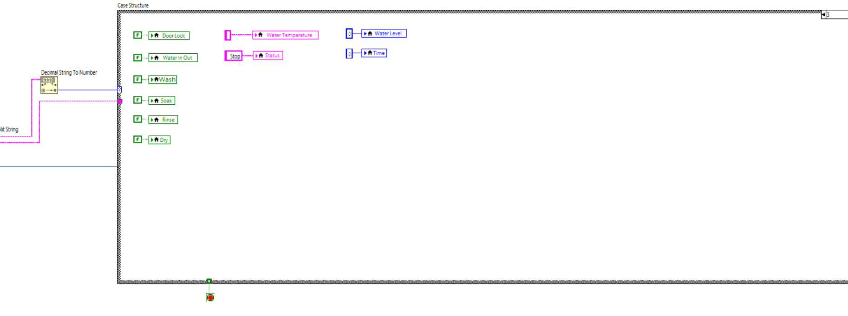

In case 3 is responsible for controlling multiple washing machine parameters, ensuring proper operation based on the selected settings. The case structure executes different washing machine functions depending on the received input. Here, data is processed using the Decimal String to Number function, which converts the incoming numerical value into a readable format. Door Lock (Green Indicator) ensures that the door is locked before the washing cycle starts. Water In/Out (Green & Yellow Indicator) controls the flow of water into and out of the washing machine. Wash, Soak, Rinse, and Dry (Green & Yellow Indicators): These indicators represent the different washing cycle stages. The system activates the corresponding indicator based on the user's selected operation. Water Temperature displays the selected water temperature for the wash cycle. Water Level (Blue Indicator) shows the water level inside the machine based on the selected setting. The time displays the remaining time for the washing operation. Status provides a status update on the washing process. Stop Button allows the user to stop the washing machine operation.

This case ensures that all necessary washing parameters, including door lock status, water flow, temperature, and washing cycle, are managed efficiently. The case structure provides a modular approach, allowing the washing machine to function based on predefined conditions while maintaining flexibility for user selections.

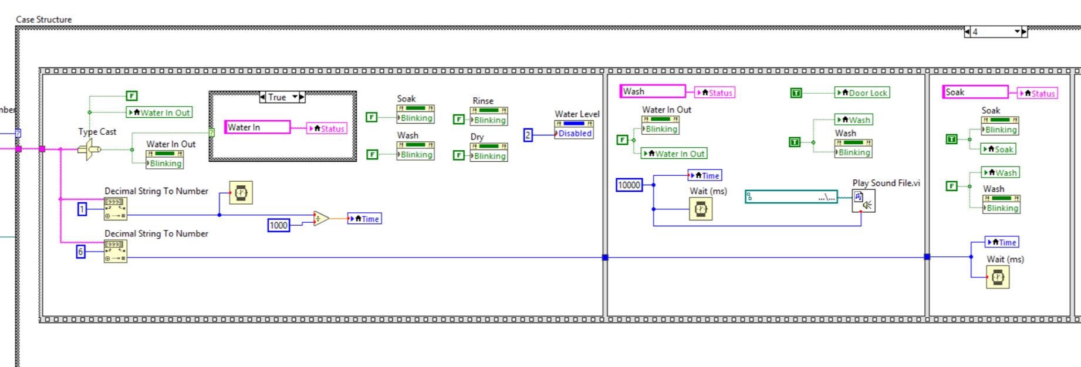

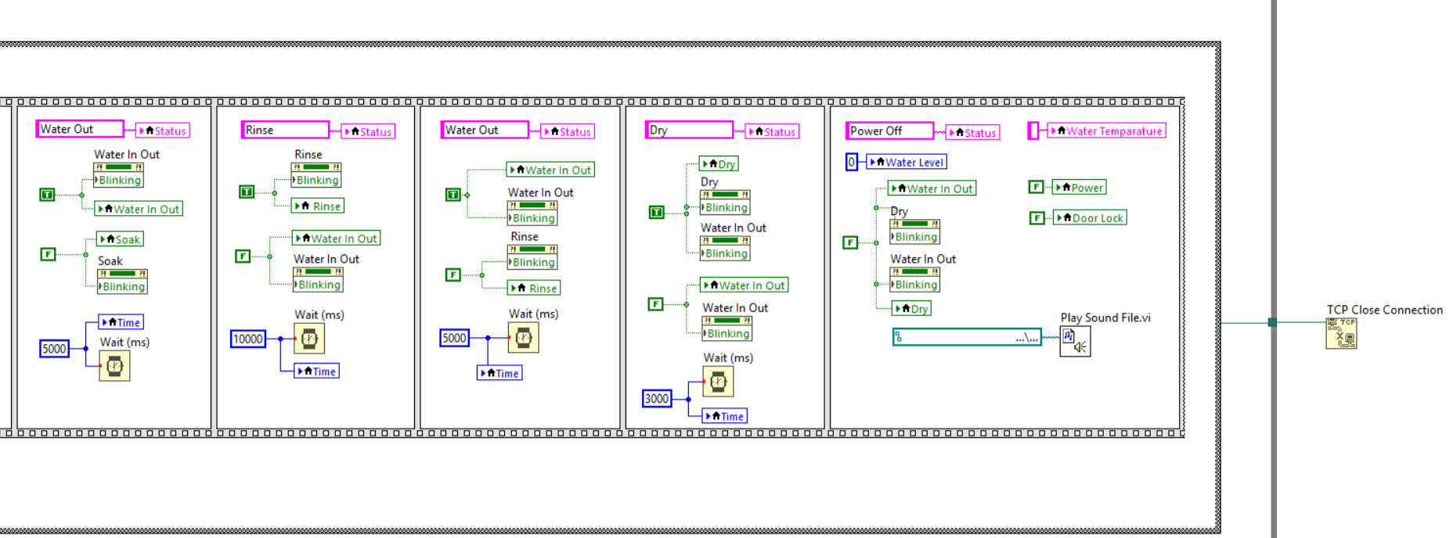

In case 4 represents the complete washing cycle of a washing machine system, covering various phases from water intake to the final drying process. Each stage follows a structured approach, ensuring the sequential execution of operations. The case includes multiple sub-processes such as water filling, washing, soaking, rinsing, drying, and shutting down. Additionally, a TCP Close Connection function is implemented at the end to terminate network communication.

The washing cycle begins with the Water In process, where water is introduced into the drum of the washing machine. During this stage, the Water In Out indicator starts blinking, signifying that the system is actively filling the drum with water. The water level is continuously monitored to ensure that a sufficient amount is present before moving forward with the washing process. Additionally, the status of the system is updated accordingly to reflect that water intake is in progress. This step is crucial, as an inadequate water level can affect the efficiency of the wash cycle. The process waits until the required water level is achieved before proceeding to the next stage.

Once the drum is filled with water, the washing cycle begins. The Wash indicator blinks, indicating that the machine is actively agitating the clothes. At this point, the Water In Out indicator remains active, showing that the water is being utilized for washing. To ensure user safety, the Door Lock mechanism is engaged, preventing any interruptions while the wash cycle is in progress. The washing process runs for a fixed duration of 10,000 milliseconds (10 seconds), as determined by the Wait function. This duration is set to allow the detergent to effectively clean the clothes. Additionally, a Sound File VI function is triggered, which plays a notification sound to signal that the washing phase has been completed.

After the main wash cycle, the system transitions into the Soak phase. This stage allows the clothes to remain submerged in water, enabling the detergent to further break down stains and dirt. During this stage, the Soak indicator blinks, providing a visual cue that the process is underway. The soak phase is essential, particularly for heavily soiled clothes, as it enhances the washing effectiveness by allowing the detergent to penetrate deeper into the fabric. The system introduces a waiting period, ensuring that the clothes remain soaked for a sufficient duration before moving to the next stage.

Once the soaking process is complete, the system proceeds to drain the used, detergent-filled water from the drum. During this stage, the Water In Out indicator blinks, signifying that the system is actively removing water. To ensure complete drainage, the system waits for 5,000 milliseconds (5 seconds). This step is essential as it prepares the machine for the rinsing cycle, ensuring that the detergent does not remain in the clothes. Proper drainage prevents detergent residues, which can cause fabric stiffness or skin irritation for users.

The Rinse phase is initiated after the water has been completely drained. In this phase, fresh water is introduced into the drum to remove any remaining detergent from the clothes. The Rinse indicator blinks, indicating that the process is in progress. Similar to the wash cycle, the machine continues agitating the clothes to ensure proper rinsing. The rinse cycle runs for 10,000 milliseconds (10 seconds), allowing enough time for all detergent residues to be washed away. Clean water is circulated through the drum during this period, and after the rinse cycle is complete, the water is again drained to prepare for the drying process.

After rinsing, the system transitions into the Dry cycle. During this phase, the Dry indicator blinks, signaling that the system is actively spinning the clothes to remove excess water. The spinning motion generates centrifugal force, which helps extract water from the fabric. This step ensures that the clothes come out of the washing machine with minimal moisture, reducing drying time. The drying process lasts for 5,000 milliseconds (5 seconds), after which the machine prepares to shut down. Additionally, a Sound File VI function is triggered, playing a sound to notify the user that the drying cycle has been completed.

Once all washing operations are completed, the washing machine proceeds to the Power Off stage. At this point, the Power indicator is turned off, and the Door Lock mechanism is released, allowing the user to open the washing machine and remove their clothes. The Water In Out indicator also stops blinking, confirming that the washing cycle has officially ended. This stage marks the end of the complete washing process, ensuring that all systems are reset and ready for the next usage cycle.

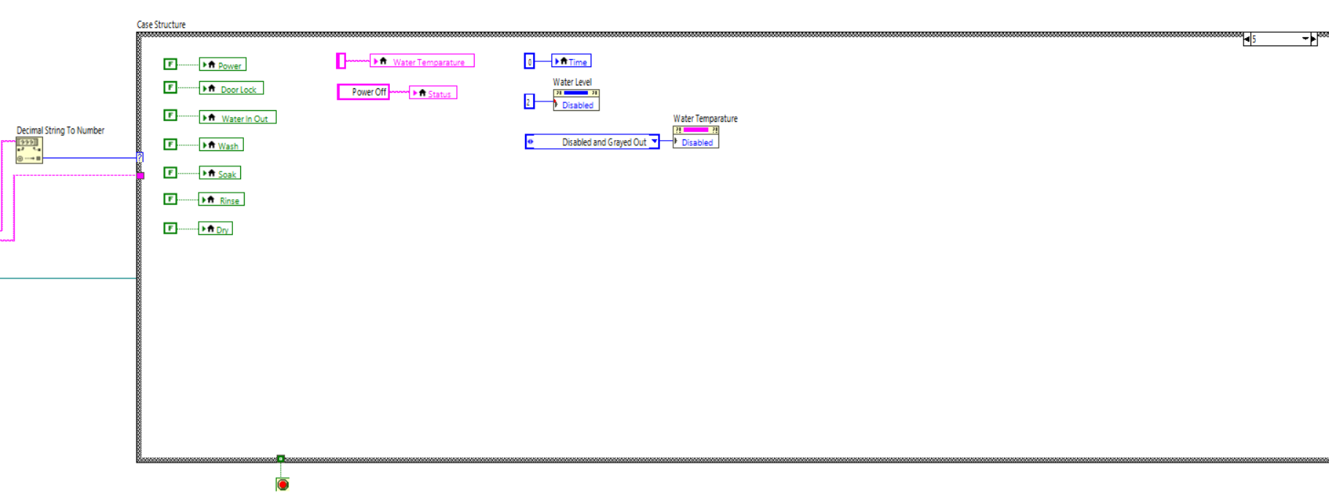

In case 5 is the power-off state in the washing machine system marks the final stage of operation, ensuring that all processes are safely shut down and the system is properly reset. This case structure is designed to terminate all active components, disable inputs, and prepare the system for its next use.

When the washing machine enters the power-off state, all major operations, including power, door lock, water in/out, wash, soak, rinse, and dry functions, are deactivated. This ensures that no washing or draining processes remain active, preventing unnecessary energy consumption or potential malfunctions. By turning off all active elements, the system ensures that the washing machine is completely idle and ready for the next cycle.

To reflect the machine's inactive state, the system updates the status indicator to "Power Off." This provides a clear visual cue to the user that the machine is no longer in operation. The status update plays a crucial role in user interaction, as it prevents any confusion about whether the washing process is still running or if it has been successfully completed.

Additionally, certain controls are disabled to prevent further interaction while the machine is powered off. The water temperature setting is deactivated, ensuring that no adjustments can be made when the system is not in use. Similarly, the water level control is set to "Disabled and Grayed Out," indicating that the machine is no longer detecting or managing water levels. These actions not only improve safety but also enhance the user experience by making it clear that the washing cycle has ended.

Finally, the system resets specific parameters such as time, setting it to zero to ensure that no active timers continue running after the washing process is completed. This reset ensures that the machine is fully prepared for its next cycle without carrying over previous settings.

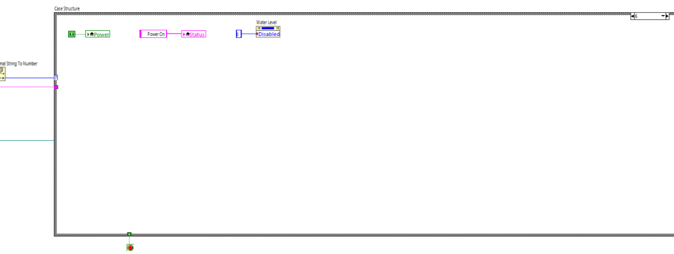

In case 6 is the power-on state in the washing machine system represents the initialization phase, where the system is activated and prepared for further operations. This case ensures that the machine is ready to proceed with various washing processes by enabling essential components and updating the system status accordingly.

When the machine is powered on, the system first activates the power function. This step ensures that the washing machine is turned on and ready for use. The power-on signal acts as the foundation for all subsequent operations, allowing the user to interact with different washing settings and functionalities. Without this activation, none of the machine’s processes can proceed.

Next, the system updates the status indicator to "Power On." This provides a clear visual representation to the user that the machine is now active and awaiting further input. The status update helps prevent confusion and ensures that the user is aware of the machine's current state, whether it is ready for operation or still inactive.

Additionally, the water level control is set to "Disabled." This indicates that, at this stage, the machine is not yet detecting or managing water levels. The water level will only become relevant when specific washing operations, such as filling the drum with water, are initiated. By keeping this setting disabled, the system prevents unnecessary operations and ensures that water intake only occurs when required.

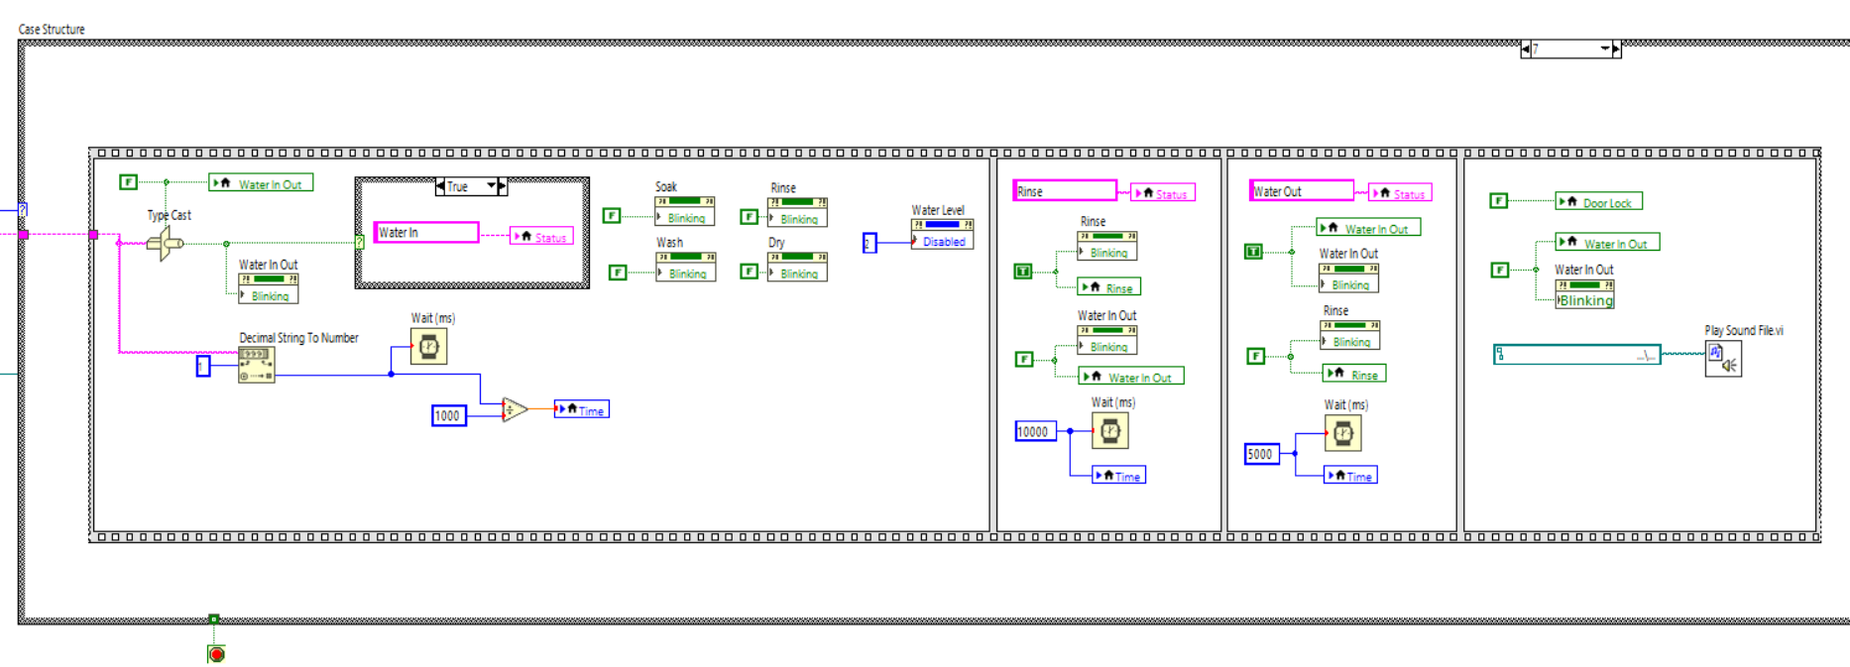

In case 7 represents the final phase of the washing process, where all operations conclude, and the system prepares to alert the user that the washing cycle is complete. This phase ensures that water is properly drained, the door is unlocked, and an audio alert is triggered to notify the user.

At this stage, the system deactivates the door lock mechanism. This means that once the washing cycle is complete, the user can safely open the washing machine door and retrieve their laundry. Unlocking the door ensures that the machine is in a safe state for user interaction.

Following the door unlock process, the water inlet and outlet functions is disabled. This indicates that no further water intake or drainage will occur, as the washing process has fully ended. Additionally, the system updates the status indicator and blinks the water in/out display to signify that the machine is no longer actively washing.

Finally, the system plays a sound file, which serves as an auditory notification to inform the user that the washing cycle has finished. This feature is particularly useful in ensuring that the user does not have to continuously check the machine and can be alerted from a distance.

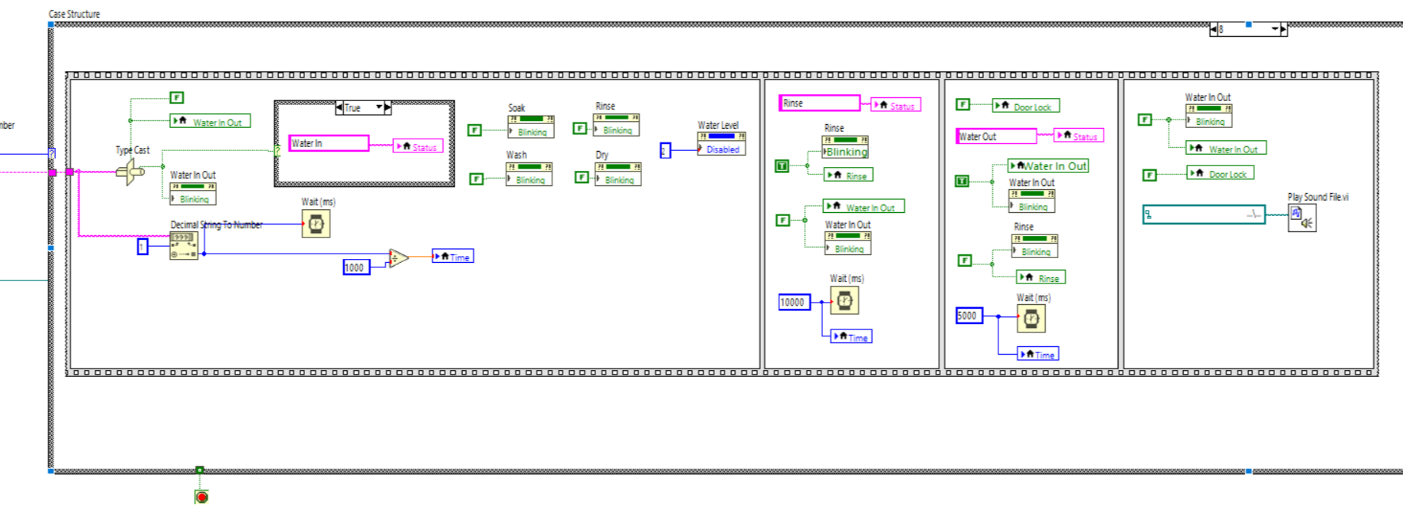

In case 8 stage mainly focuses on the controlled release of water, unlocking the door for user access, and playing an alert sound to signal the completion of the cycle.

At the beginning of this case, the system activates the water outlet function, ensuring that any remaining water inside the machine is drained completely. The blinking indicator for water in/out remains active, visually confirming that this process is taking place. To prevent accidental interruptions, the door remains locked during this phase, ensuring safety while the machine finishes draining.

Once the water is drained, the system disables the door lock, allowing the user to open the washing machine safely. This step ensures that all operations have ceased before access is granted. At the same time, the water in/out function is also deactivated, indicating that no further water flow is required.

Finally, to notify the user that the washing cycle is officially complete, the system plays a sound file. This auditory alert allows the user to know that their laundry is ready, even if they are not directly near the machine. The inclusion of both visual and audio indicators ensures that the system is user-friendly and accessible.

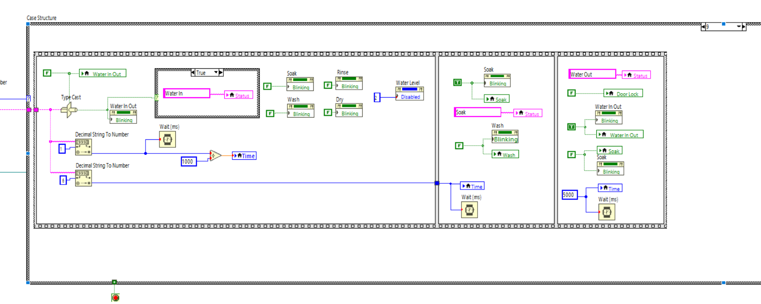

In case 9 of the washing machine system, the primary operation involves the water draining process and transitioning to the next phase of the wash cycle. At this stage, the system ensures that the soaking process is completed and prepares for the washing cycle by draining excess water.

The case begins with an update to the system status, indicating that the current operation is "Water Out." To execute this process, the water outlet function is activated, and a blinking indicator visually confirms that water is being removed from the drum. The door lock remains engaged to prevent user interference while the machine is still in operation.

Additionally, the soaking indicator remains active to signify that the cycle has not yet fully transitioned to washing. The system then introduces a timed wait period of 5000 milliseconds, allowing the water drainage process to complete before proceeding. This ensures that the washing machine is ready for the next stage without any excess water remaining.

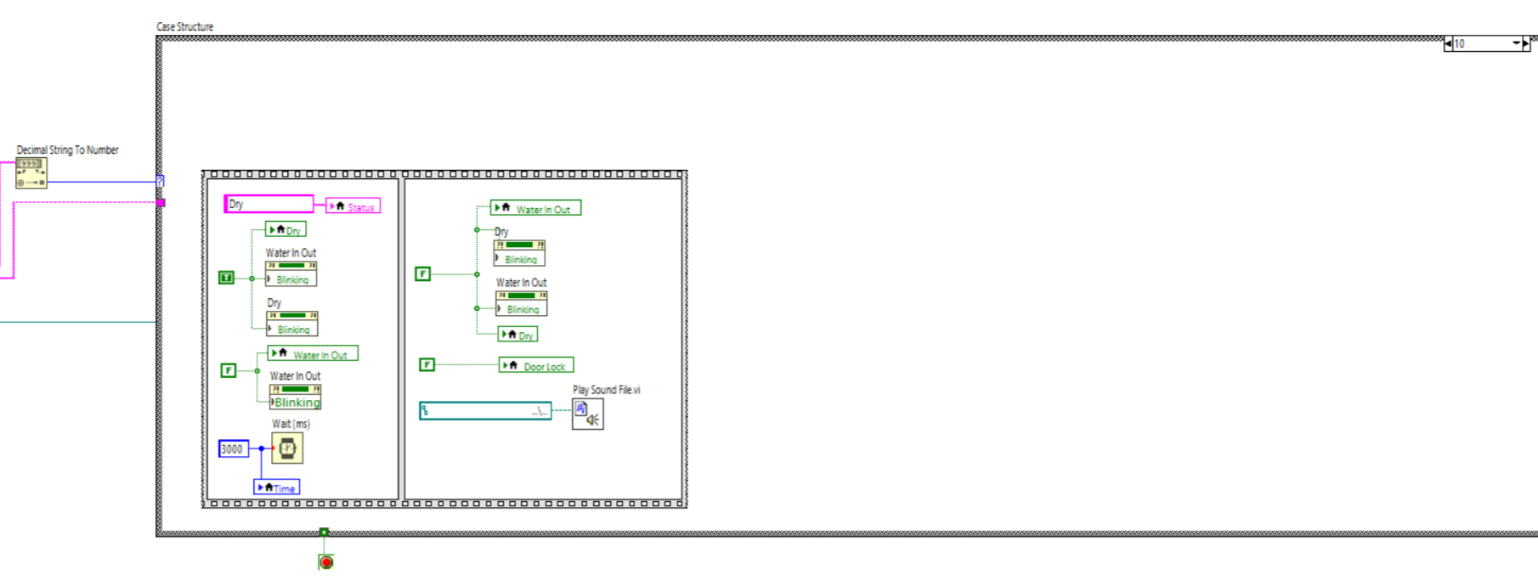

In case 10 of the washing machine system, the primary function is to execute the drying process and provide a completion notification. At this stage, the system updates its status to indicate that the drying phase has started. The drying mechanism is activated, and the corresponding indicators begin blinking to show that the drying process is ongoing.

Additionally, the water inlet and outlet functions are also blinking, ensuring that any residual water is managed during the drying phase. A wait function of 3000 milliseconds is introduced, allowing sufficient time for the drying operation to take effect before moving to the next step.

After the drying cycle, the system proceeds to finalize the process by keeping the drying and water indicators active. The door lock remains engaged to ensure safety while the machine is still in operation. Finally, a sound file is played as an alert to notify the user that the washing and drying process has been completed.

This case represents the final phase of the washing cycle, ensuring that clothes are properly dried and that the user receives a notification upon completion.

# Limitations/Extensions/Suggestions

Despite the advanced functionalities of the Washing Machine Controller System, certain limitations must be addressed to enhance its real-world applicability. One major limitation is its reliance on software-simulated sensors rather than physical hardware. While the current implementation effectively emulates machine operations, additional modifications would be necessary for real-world deployment. The absence of physical sensors limits the system’s ability to accurately detect and respond to real-time washing conditions, such as precise water levels or fabric weight.

Another limitation is the lack of energy efficiency features. The prototype does not incorporate load detection mechanisms that could optimize water and electricity consumption based on the weight of the laundry. Implementing such a feature would not only enhance sustainability but also reduce operational costs in large-scale laundry businesses. Additionally, the system's WAV-based audio alert, while functional, may pose compatibility issues on certain devices, potentially affecting its ability to notify users effectively.

Security and scalability also present challenges in the current system. The use of a text file for user authentication is a functional but basic approach that lacks the robustness of a database-driven system. Text file storage is not ideal for handling large numbers of users or ensuring advanced security features such as encrypted credentials and multi-user access levels. Upgrading to a more secure and scalable authentication method would greatly improve the system’s reliability.

Several extensions can be implemented to improve the efficiency and expand the capabilities of the system. Integrating Internet of Things (IoT) technology would allow remote operation and real-time monitoring through cloud-based services. This enhancement would enable users to control their washing machines from any location, ensuring greater convenience and efficiency. Additionally, replacing the existing PIN-based authentication system with RFID technology would provide a more secure and seamless access control mechanism, reducing the risk of unauthorized use.

Another potential extension is the development of a mobile application, which would further enhance user accessibility. With a dedicated app, users could remotely control washing machine operations, receive real-time cycle updates, and adjust washing settings as needed. This feature would be particularly useful for commercial laundry services and users managing multiple machines at once.

Future enhancements could also include the integration of real-world sensors for precise water level and weight detection, allowing the system to optimize water and detergent usage automatically. Additionally, implementing energy-efficient algorithms would enable the washing machine to adjust its cycle based on the load size, reducing power consumption and improving sustainability. Enhanced security features, such as biometric authentication, could further strengthen user access control, preventing unauthorized use while improving convenience. Furthermore, a feedback mechanism that sends notifications via SMS or mobile alerts would provide users with real-time updates on cycle completion, ensuring better user engagement.

By addressing these limitations and incorporating these extensions, the Washing Machine Controller System can evolve into a more intelligent, efficient, and user-friendly solution. With advancements in hardware integration, security, and remote accessibility, the system has the potential to revolutionize modern laundry automation, making it more reliable and effective for both commercial and personal use.

# User Manual

To operate the Washing Machine Controller System, users must follow these guidelines:

First and foremost, users must launch the application by clicking operate and then run.

  
The Washing Machine Controller User Manual provides essential guidance for users to operate the system efficiently. Upon launching the application, users must log in using their assigned username and password. A successful login is indicated by a green light, while an incorrect attempt will not trigger any lights until the correct credentials are entered.



Once logged in, users will be directed to the menu page, where they can choose between managing user accounts or operating the washing machine.



If users select the manage user page, they can add or delete usernames and passwords. Any newly added credentials will be automatically saved in the text file, allowing future logins. Conversely, deleted users will no longer have access, as their details will be removed from the system. Users can navigate back to the menu by clicking the "Back" button.



If users proceed to the washing machine page, they can control the machine's operations. The system allows users to turn the washing machine on or off and adjust the water level according to the amount of laundry, with the selected level displayed on the right icon. Additionally, users can set the water temperature to either hot or cold. Various washing modes are available, including normal wash, wash, soak, rinse, and dry. If selecting the soak function, users can choose a duration of 10, 20, or 30 minutes. Once all settings are configured, the user can start the washing process by clicking the "Start" button or terminate it using the "Stop" button.

# Conclusion

The LabVIEW-based Washing Machine Controller System successfully demonstrates the feasibility of automating washing machine operations within a networked environment. By integrating user authentication, machine control, and remote communication, the system enhances efficiency, security, and user convenience. Its ability to centralize control while ensuring real-time monitoring optimizes washing machine operations, making it a significant step toward modernizing laundry automation.

Despite its advantages, the system does have certain limitations, particularly in terms of hardware integration. The reliance on simulated sensors rather than physical components limits its real-world applicability, and the absence of advanced security features may affect scalability. However, with future improvements, such as the integration of Internet of Things (IoT) technology, RFID-based authentication, and the development of a mobile application, the system’s capabilities can be further expanded. These enhancements would allow for remote operation, smarter access control, and real-time notifications, making it an even more efficient and user-friendly solution.

This project lays a strong foundation for the future development of intelligent laundry solutions. By incorporating additional smart features and real-time user alerts, the system can evolve into a comprehensive automation tool that benefits both commercial and residential laundry settings. As technology continues to advance, further refinements in energy efficiency, security, and hardware integration will make such systems indispensable in modern laundry operations, paving the way for greater automation and operational efficiency.

# Appendices

Appendix A: Understanding LabVIEW Basics and Interface Design

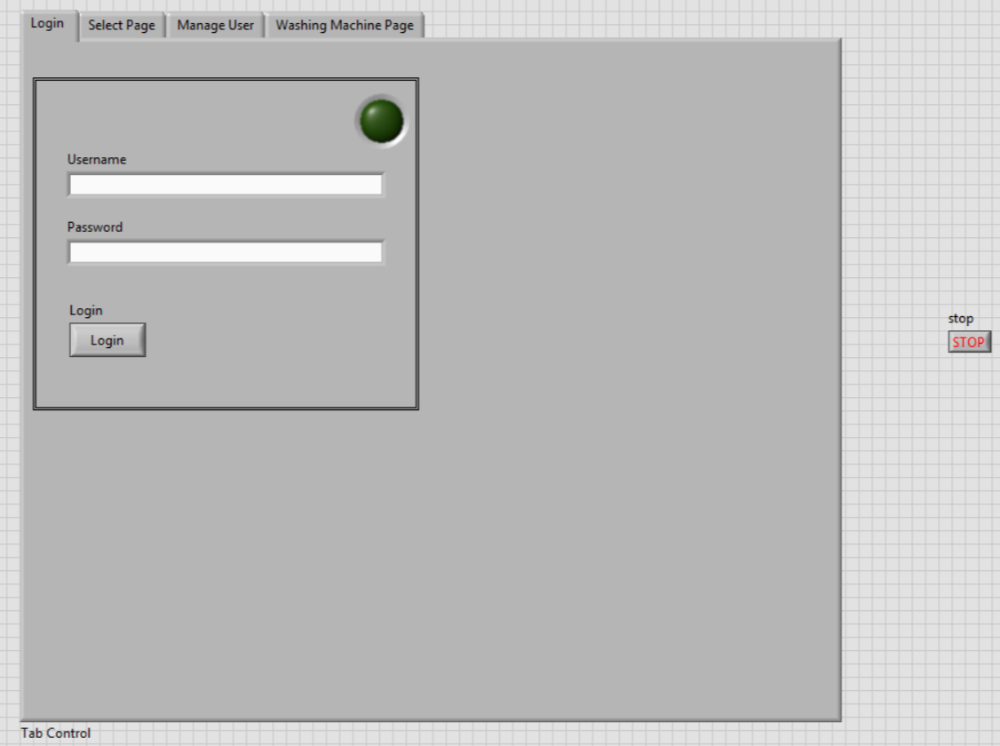

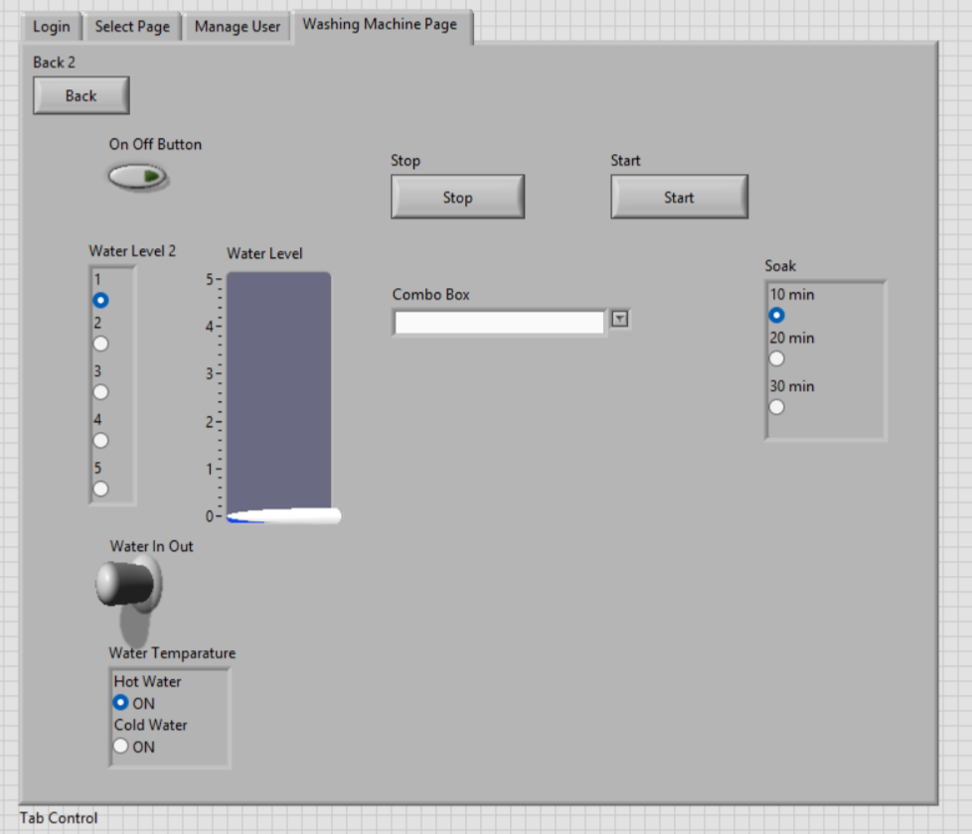

LabVIEW (Laboratory Virtual Instrument Engineering Workbench) is a graphical programming environment widely used for system design and testing. This appendix covers the essential aspects of the LabVIEW interface and how it was structured for the washing machine simulation.

The Front Panel serves as the user interface where users can control and monitor the washing machine functions. The interface includes control elements like start and stop buttons, cycle selection dropdown, and water level adjustment. The indicators display wash cycle status, timer, and real-time water level. The graphical enhancements such as icons, a menu page with buttons, LED, and indicators for an intuitive user experience.

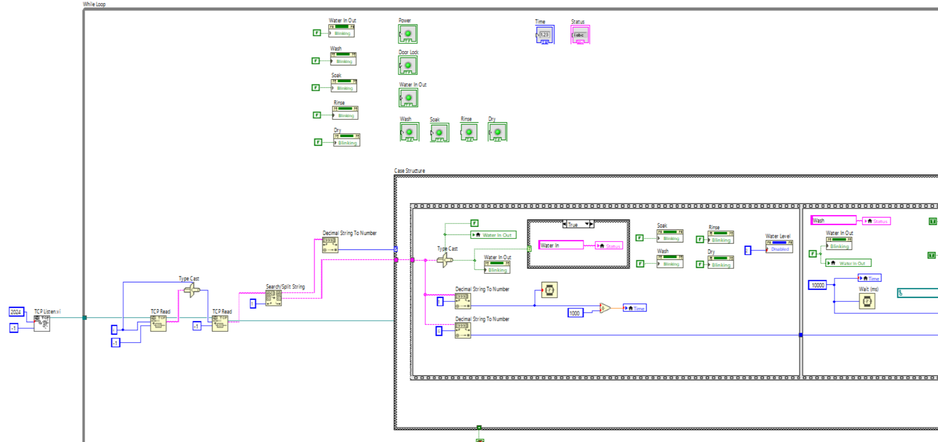

The Block Diagram contains the underlying logic of the washing machine program. It includes case Structures for different washing cycles (normal wash, soak, wash, rinse, and dry). Event Structures to manage user interactions such as button presses. Loops to implement repetitive tasks, such as continuously updating the timer and monitoring sensor inputs.

Appendix B: Implementing TCP/IP Communication in LabVIEW

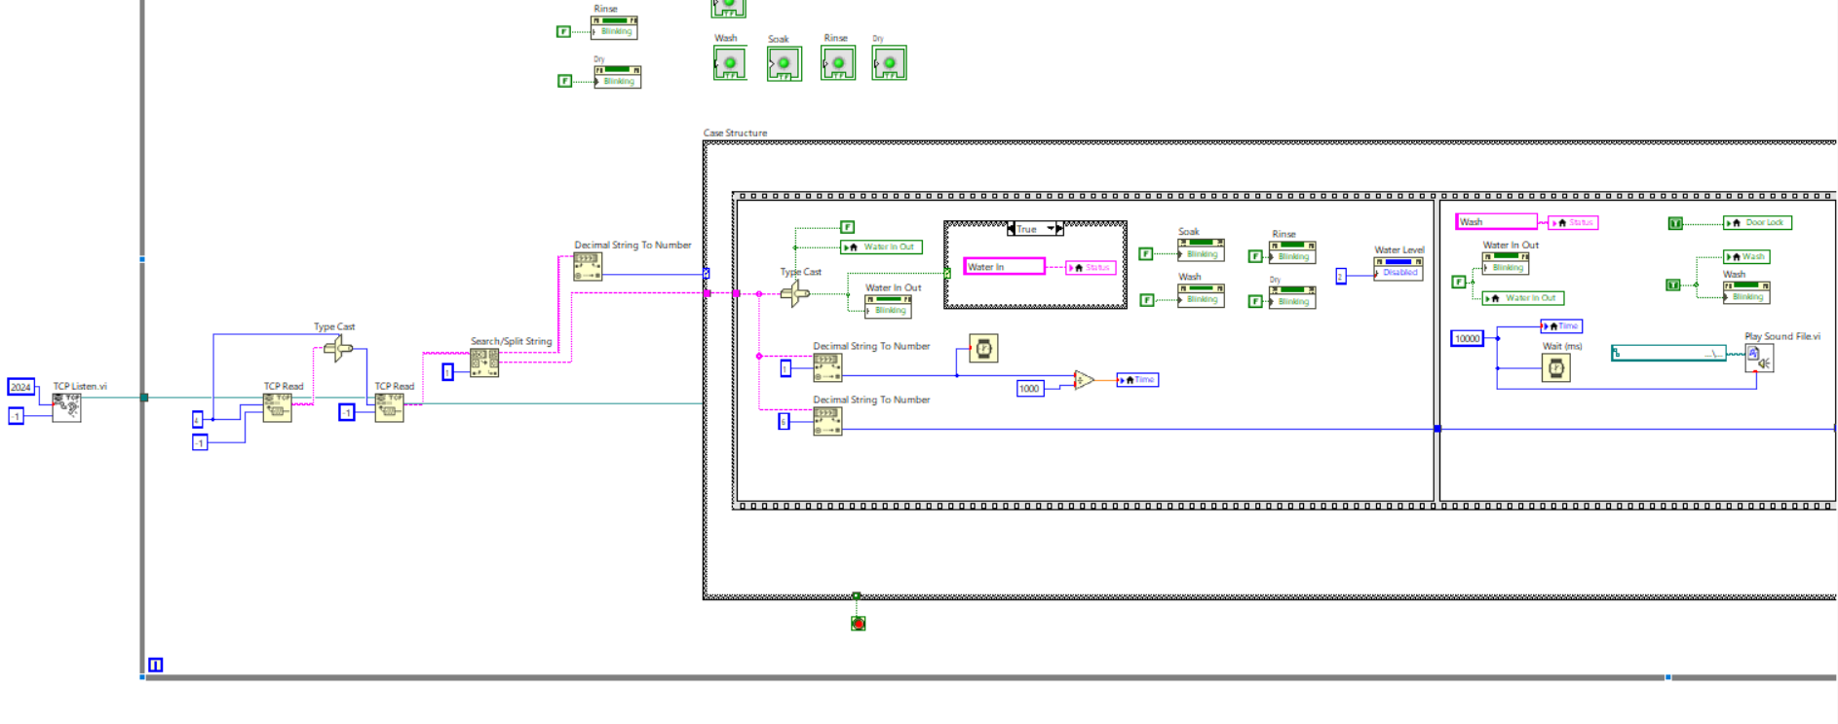

In this project, TCP/IP communication is used to remotely control and monitor the washing machine. TCP (Transmission Control Protocol) allows data exchange between a client (user interface) and a server (washing machine controller). TCP Listener.vi is set up on the washing machine controller to wait for incoming connections. The user interface (client) sends commands, such as selecting a wash cycle or stopping the machine, via TCP Write.vi. The washing machine controller processes the command and responds using TCP Read.vi. Data such as the current washing stage, timer updates, and error messages are sent back to the user interface.

Appendix C: Developing Software Sensor Simulations for Washing Machines

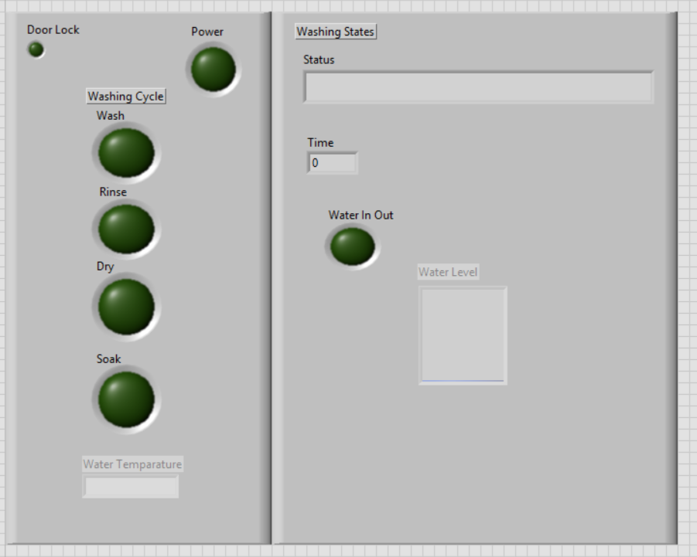

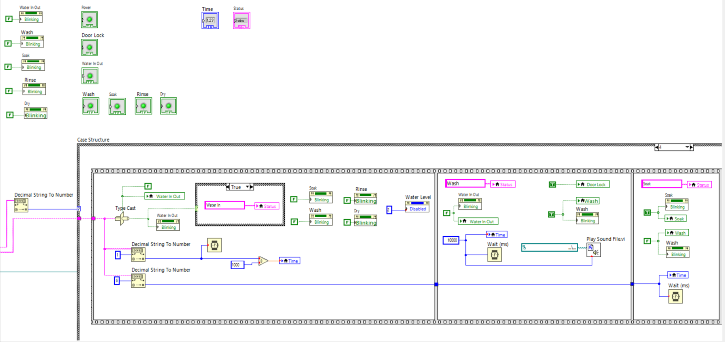

LabVIEW enables the simulation of real-world sensors to emulate washing machine operations accurately. Simulated sensors, Water Level Sensor measures the water level in the drum and triggers an alert if it exceeds the maximum limit. Temperature Sensor monitors water temperature and ensure it remains within a safe range. The Door Lock Sensor prevents the washing cycle from starting if the door is open.

Implementing Time-Based Control Delays for Soaking and Rinsing, implemented using the Wait (ms) function to simulate real-time processing. Cycle Timers are used to track and update the washing cycle duration dynamically. Real-Time Indicators Blinking Water Flow Indicator uses a Boolean LED indicator that blinks during the filling process. Mathematical Functions used to control water flow and temperature adjustments dynamically.

Appendix D: Creating a User Authentication System with File Storage

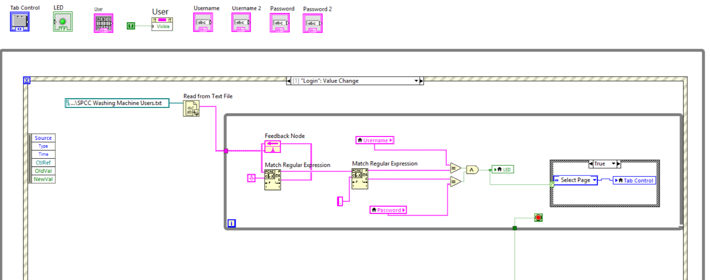

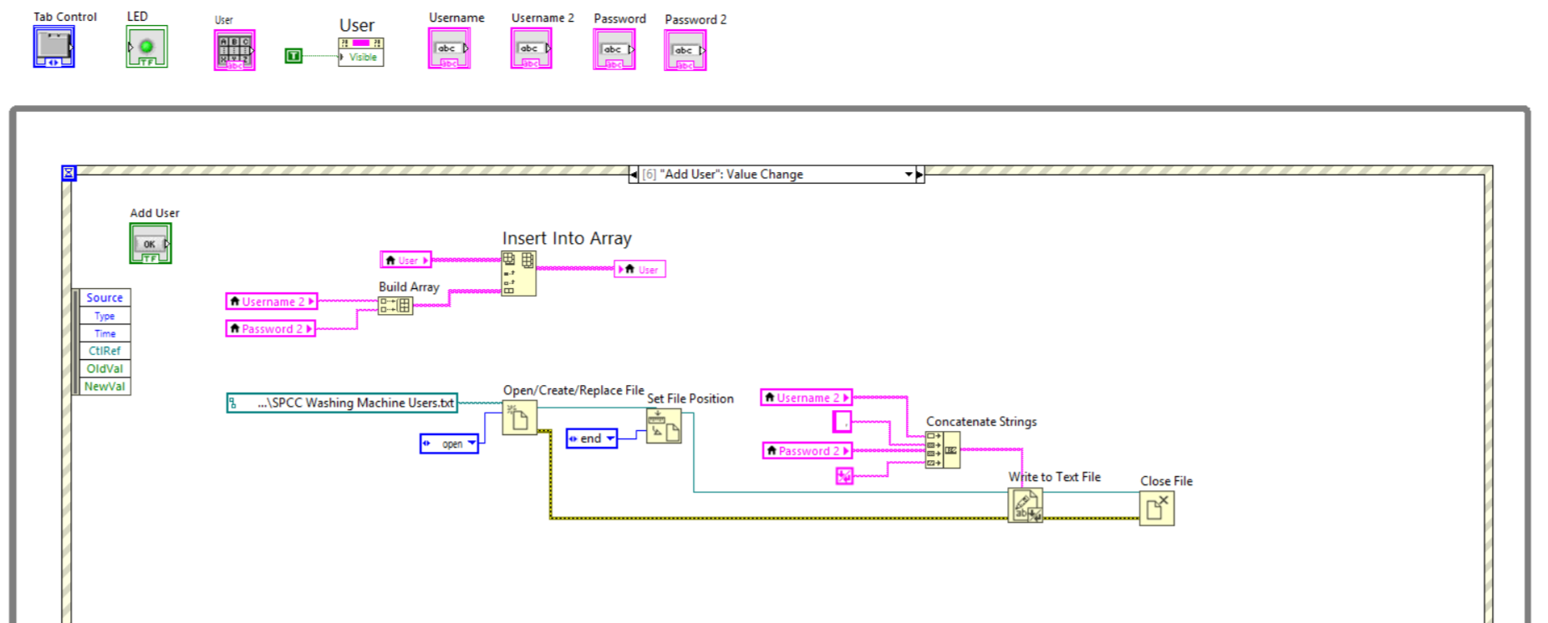

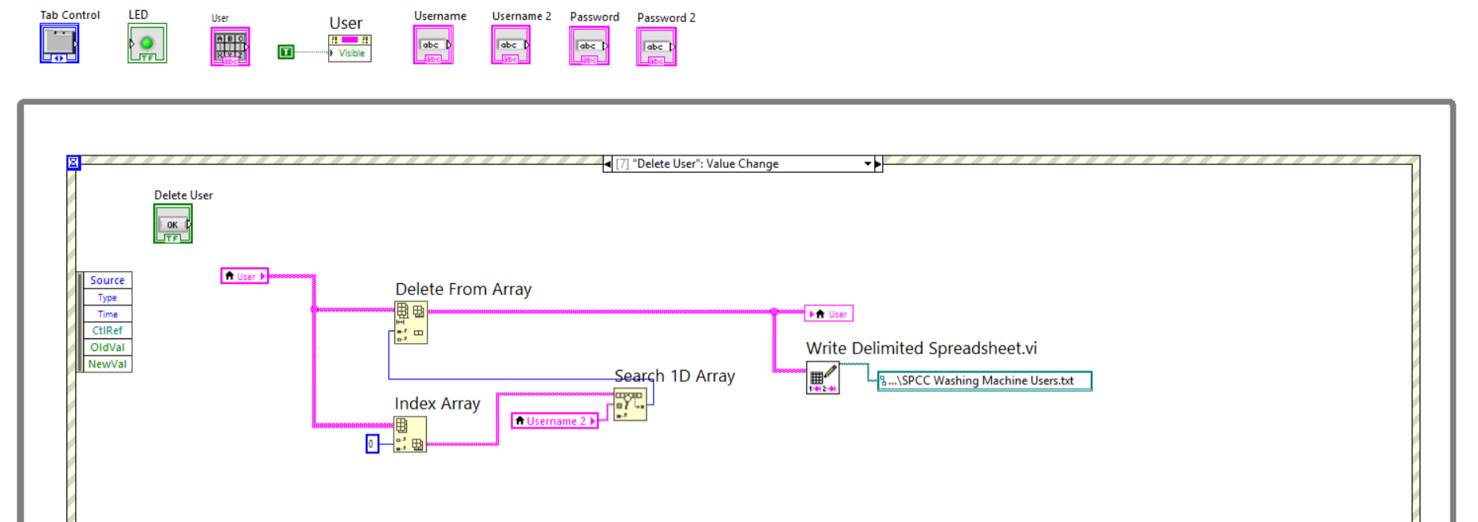

The system includes a user authentication feature that ensures only authorized users can operate the washing machine. User credentials storage is a text file that stores usernames and passwords in an encrypted format. The login process includes the user entering their credentials, LabVIEW reads the stored data and compares it to the entered credentials. If the credentials match, access is granted otherwise, an error message is displayed. User registration and removal new users can be added to the system using a registration function. The system can also remove users by modifying the text file using the delete button.

The File Read/Write Operations, reading user data is implemented using Read from Text File.vi to retrieve stored usernames and passwords. Writing new users is implemented using Write to Text File.vi to add new users or update credentials.

Validation using regular expressions, and password complexity ensures that passwords meet security requirements (use appropriate characters and numbers). The comparison logic uses String Comparison.vi to validate entered credentials against stored data.

Sample physical and logical washing machine design

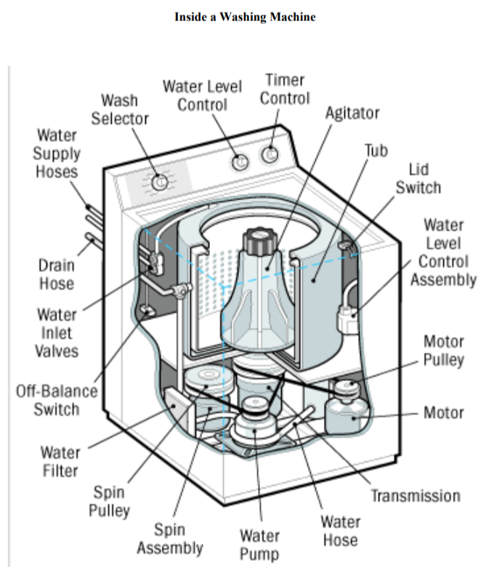

# References